A Major-Project Report
On

HISTOPATHOLOGY-DRIVEN DETECTION OF LUNG & COLON CANCER USING DEEP LEARNING
Submitted in partial fulfilment for the Degree of B.Tech.
In
Artificial Intelligence
By
SHRIYANS DENIS [22911A35B4] SHAIK RAHEEM [23915A3511] OM KHUNE [22911A35C8]
PRANAY REDDY [22911435A4]

Under the guidance of

Mr. Dr. Pemula Rambabu Associate Professor - Department of AI

DEPARTMENT OF ARTIFICIAL INTELLIGENCE
VIDYA JYOTHI INSTITUTE OF TECHNOLOGY
(An Autonomous Institution)
[Accredited by NAAC & NBA, Approved by AICTE New Delhi & Permanently Affiliated to JNTUH]
2024-2025


[Accredited by NAAC & NBA, Approved by AICTE New Delhi & Permanently Affiliated to JNTUH]

CERTIFICATE

This is to certify that the project report entitled “HISTOPATHOLOGY- DRIVEN DETECTION OF LUNG & COLON CANCER USING
DEEP LEARNING” submitted by Shriyans Denis (22911A35B4) , Shaik Raheem (23915A3511), Om Khune (22911A35C8) & Pranay Reddy (22911A35A4) to Vidya Jyothi Institute of Technology(An Autonomous Institution), Hyderabad, in partial fulfilment for the award of the degree of
B. Tech. in Artificial Intelligence a bonafide record of project work carried out by us under my supervision. The contents of this report, in full or in parts, have not been submitted to any other Institution or University for the award of any degree.

Signature of Supervisor Signature of Head of the Department

Mr. Dr. Pemula Rambabu Assistant Professor
Department of Artificial Intelligence
Dr. A. Obulesh Associate Professor
Department of Artificial Intelligence

Signature of External Examiner

DECLARATION

We declare that this project report Histopathology-Driven detection of Lung & Colon Cancer using Deep Learning by us under the supervision of Dr. Pemula Rambabu, and has not formed the basis for the award of any other degree or diploma, in this or any other Institution or University. In keeping with the ethical practice of reporting scientific information, due acknowledgements have been made wherever the findings of others have been cited.

Shriyans Denis (22911A35B4) Shaik Raheem (23915A3511) Om Khune (22911A35C8)
Pranay Reddy (22911A35A4)

Date:

ACKNOWLEDGEMENTS

We wish to express our heartful thanks to Dr. Pemula Rambabu, for guiding and supporting us throughout the course.

We extend our heartfelt thanks to Dr. A. Obulesh, Associate Professor, for his invaluable mentorship and guidance throughout the project. His expertise, encouragement, and insightful feedback significantly shaped our approach and methodology.

We sincerely extend our heartfelt gratitude to Principal Dr. A. Srujana, Dean Accreditations & Rankings Dr. A. Padmaja, and Dean Academic Coordinator Mrs. G. Sreelatha for their invaluable support and unwavering encouragement throughout the course.

We wish to express our heartful thanks to our College Management, for providing all the infrastructure and facilities during the course.

We would like to express our sincere gratitude to our Parents and Friends, for their unwavering support throughout the completion of this major project.

Shriyans Denis (22911A35B4) Shaik Raheem (23915A3511) Om Khune (22911A35C8)
Pranay Reddy (22911A35A4)

ABSTRACT

Early diagnosis of lung and colorectal cancers remains a major challenge due to high pathologist workload, inter-observer variability, and limited access to specialized expertise. This project presents an AI-based system for automated detection of lung and colon cancer using digitized histopathology (H&E) images. The proposed pipeline ensures reliable and unbiased evaluation through a leakage-safe data handling approach, incorporating perceptual hashing (pHash), structural similarity index (SSIM), and GroupKFold-based dataset splitting to eliminate duplicate and near- duplicate samples.

The input images undergo preprocessing steps including resizing, normalization, and Macenko stain normalization to reduce variability across tissue samples. A ConvNeXt- Small deep learning architecture is employed for feature extraction and classification, trained using the AdamW optimizer with learning rate scheduling and mixed precision techniques to achieve efficient and stable performance.

To improve interpretability, Grad-CAM is integrated to generate visual heatmaps highlighting the pathological regions influencing model predictions. The system is evaluated using metrics such as precision, recall, F1-score, AUROC, and confusion matrix analysis, ensuring comprehensive performance assessment.

For real-world applicability, the trained model is exported to ONNX format with optional INT8 quantization, enabling efficient deployment on both CPU and GPU environments. The proposed system provides a scalable, explainable, and deployment- ready solution for assisting pathologists in early cancer detection and improving diagnostic efficiency.
TABLE OF CONTENTS

ABSTRACT i
LIST OF FIGURES vi
LIST OF TABLES viii
CHAPTER 1: INTRODUCTION 1
  - Introduction 1
  - Problem Description 1
  - Motivation 2
  - Objective 2
CHAPTER 2: LITERATURE SURVEY 4
  - Drone-Based Real-Time Surveillance 4
  - Object Detection Algorithms 4
  - Feature Extraction and Re-Identification 5
  - Kalman Filter-Based Tracking 5
  - Data Annotation and Dataset Preparation 6
  - Optimization and Future Directions 6
  - Conclusion 10
CHAPTER 3: METHODOLOGY 11
  - Overview of Methodology 11
  - Hardware Methodology 11
    - 720 Magnetic Micro Coreless Motors 11
    - RLD-202R Flight Controller 13
    - ESP32-CAM Module 14
    - 3D Printed Mini Drone Frame (PLA Plastic) 14
    - High Discharge LiPo Battery (3.7 V) 15
    - Propellers 16
    - Jumper Wires 17
    - A1251-02Y-1.25mm 2-pin Female Housing Connector with 300mm Wire (30 AWG) 17
  - System Architecture 18
  - Hardware Specifications 19
    - Flight Controller Configuration 19
    - Power and Electronics Specifications 19
  - Software Methodology 19
    - Ground Station Software 19
    - Telemetry and Control Logic 19
CHAPTER 4: DATA COLLECTION AND CUSTOM DATASET TRAINING 20
  - Data Collection 20
    - Drone-Assisted Data Capture 20
  - Annotation with LabelImg 20
  - Custom Dataset Training 21
CHAPTER 5: OBJECT DETECTION AND TRACKING—THEORY, YOLOV8 IMPLEMENTATION, AND ARDUINO INTEGRATION 23
  - Introduction to Object Detection 23
    - Traditional Approaches vs. Deep Learning 23
    - Detailed Steps of Object Detection with CNNs 23
  - Object Tracking: Principles and Techniques 24
    - What is Object Tracking? 24
    - Types of Tracking Algorithms 25
    - Kalman Filter 25
      - Importance of Kalman Filter in Object Tracking 26
      - Mathematical Foundation of Kalman Filter 27
      - Handling Occlusions and Missed Detections 28
      - Why Use Kalman Filtering? 29
  - Feature Extraction for Object Re-Identification 29
    - EfficientNet B0: High-Precision Feature Extraction 30
  - YOLO Algorithm: An In-depth Exploration 31
    - Historical Context and Evolution 31
    - How YOLO Works 32
    - Why YOLO is Efficient 32
  - Introducing YOLOv8: Improvements and Implementation 33
    - Why YOLOv8? 33
  - Advantages of YOLOv8 Over Alternative Models 34
  - Detailed Code Explanation 35
    - Initialization and Library Imports (Python Code) 35
    - ESP32-CAM Integration and Frame Acquisition 36
    - Real-Time Object Detection Using YOLOv8 37
    - Feature Extraction with EfficientNet B0 for Robust Identification 38
    - Predictive Object Tracking Using Kalman Filtering 39
    - Interactive User Control and Real-Time Visualization 40
    - System Workflow and Continuous Processing Loop 42
  - Training Results 47
    - F1-Confidence Curve 47
    - Precision-Confidence Curve 48
  - Implications for Deployment 49
  - Arduino-Based ESP32 Camera Web Server Implementation 49
    - Overview and Purpose 49
    - Library and Dependency Imports 49
    - Wi-Fi Configuration and Connection 50
    - Camera Hardware Initialization and Configuration 51
    - GPIO Pin Definitions (camera_pins.h) 52
    - HTTP Web Server Implementation (app_httpd.cpp) 53
    - User Interface via HTML (camera_index.h) 55
    - Main Program Loop and Continuous Operation 56
    - System Operation Summary and Block Diagram 56
CHAPTER 6: GRAPHICAL USER INTERFACE DEMONSTRATION, RESULTS AND DRONE PERFORMANCE ANALYSIS 59
  - Introduction to the Graphical User Interface 59
  - GUI Code explanation 60
    - Recording and Snapshot Functionality 60
    - Detection and Tracking Toggle Mechanism 61
    - Futuristic Visual Theme 61
    - Dynamic Resizing and Aspect Ratio Handling 62
    - Integrated Zoom Control System 63
  - Physical Drone Model Overview 65
  - Drone Performance Analysis and Thrust Calculation 67
CHAPTER 7: FUTURE ENHANCEMENTS 70
7.1 Future Enhancements 70
CHAPTER 8: CONCLUSION 72
  - Conclusion 72
  - Future Work 73
CHAPTER 9: REFERENCES 74

LIST OF FIGURES

FIGURE NO. | TITLE | PAGE NO.
3.1 | Coreless Motors | 12
3.2.1 | RLD-202R Flight Controller Top view | 13
3.2.2 | RLD-202R Flight Controller Rear View | 13
3.3 | ESP-32 Camera Module | 14
3.4.1 | 3D Printed Frame Top View | 15
3.4.2 | 3D Printed Frame Front View | 15
3.5 | High Discharge 3.7V Drone Battery | 16
3.6 | Propellers | 16
3.7 | 1.25mm 2-pin Female Housing Connector | 17
3.8 | Flow Chart of System Architecture | 18
4.1 | LabelImg Software | 21
5.1 | Object detection and Tracking | 24
5.2 | Kalman Filter in Object Detection | 26
5.3 | Architecture of EfficientNet-B0 | 31
5.4 | Performance Analysis of YOLOv8 vs Lower YOLO  Versions | 34
5.5 | Flow Chart of System Architecture | 46
5.6 | F1-Confidence Curve | 47
5.7 | Precision-Confidence Curve | 48
5.8 | ESP32-CAM Module Setup and Interaction | 57
6.1 | Graphical User Interface with object detection | 64

6.2 | Graphical User Interface with object tracking | 65
6.3 | Drone Model | 66
6.4 | Thrust calculation illustration | 68

LIST OF TABLES

TABLE NO. | TITLE | PAGE NO.
2.1 | Literature Survey | 7,8,9,10
2.4 | Dataset Statistics | 22

CHAPTER 1 INTRODUCTION

Introduction

In recent years, the field of medical diagnosis has witnessed significant advancements with the integration of Artificial Intelligence (AI) and deep learning technologies. Among various diagnostic techniques, histopathology—microscopic examination of tissue samples—remains the gold standard for detecting diseases such as lung and colon cancer. However, traditional histopathological analysis is time- consuming, labor-intensive, and highly dependent on the expertise of pathologists.
With the increasing number of biopsy samples and growing demand for accurate diagnosis, there is a need for automated systems that can assist medical professionals in identifying cancerous patterns efficiently. AI-based image analysis systems have shown great potential in detecting complex tissue structures and patterns that may not be easily distinguishable through manual observation.
This project focuses on developing a Histopathology-Driven Detection System for Lung and Colon Cancer using deep learning techniques. The system processes digitized Hematoxylin and Eosin (H&E) stained images and automatically classifies them into different cancer categories. Additionally, the system provides visual explanations using Grad-CAM heatmaps, enabling better interpretability and trust in predictions. Unlike traditional approaches, the proposed system also emphasizes deployment readiness and scalability, making it suitable for real-world medical applications.

Problem Description

Early detection of lung and colorectal cancers is critical for improving patient survival rates. However, conventional histopathological diagnosis faces several challenges. Pathologists often deal with a high volume of biopsy samples, leading to increased workload and longer diagnosis times.
Moreover, manual interpretation of tissue samples can result in inter-observer variability, where different experts may provide slightly different diagnoses.
Existing computer-aided diagnosis (CAD) systems attempt to address these issues but suffer from multiple limitations. Many systems rely on basic deep learning models without proper data validation strategies, leading to issues such as data leakage, which produces overly optimistic results. Additionally, most models operate as black-box systems, providing predictions without explainability, making them less reliable for clinical use.
Furthermore, variations in staining techniques, imaging conditions, and tissue structures introduce inconsistencies in histopathology images, reducing the generalization capability of existing models. Many systems also lack deployment readiness, limiting their applicability in real-world healthcare environments.

Motivation

The limitations of traditional diagnosis methods and existing AI systems motivate the development of a more reliable, explainable, and scalable cancer detection solution. By leveraging modern deep learning architectures and robust data handling techniques, it is possible to build a system that not only achieves high accuracy but also maintains fairness and reliability in evaluation.
The motivation behind this project is to design an intelligent system that reduces the workload of pathologists while improving diagnostic consistency. By incorporating leakage-safe dataset handling techniques such as de-duplication using perceptual hashing (pHash) and Structural Similarity Index (SSIM), the system ensures unbiased model evaluation.
Additionally, integrating explainable AI techniques such as Grad-CAM allows the system to highlight important tissue regions responsible for predictions, increasing clinical trust. The use of deployment- friendly technologies such as ONNX and model optimization further ensures that the system can be integrated into real-world diagnostic workflows.

Objective
The primary objective of this project is to design and implement an AI-based system for automated detection of lung and colon cancer using histopathology images. The system aims to improve diagnostic efficiency, reduce manual effort, and provide reliable and interpretable predictions.
This project outlines the following key objectives:

- Automated Cancer Detection: Develop a deep learning-based system capable of accurately classifying histopathology images into cancer categories.
- Leakage-Safe Data Handling: Implement robust data preprocessing techniques including de- duplication and grouped dataset splitting to ensure fair and unbiased evaluation.
- Advanced Feature Extraction: Utilize modern architectures such as ConvNeXt-Small to capture complex tissue patterns and improve classification performance.
- Explainable AI Integration: Incorporate Grad-CAM to generate heatmaps that highlight important regions influencing model predictions.
- Performance Optimization: Ensure high accuracy, stability, and generalization through techniques such as augmentation, normalization, and efficient training strategies.
- User-Oriented Design: Provide meaningful outputs including predicted class, probability scores, and visual explanations to assist medical professionals in decision-making.
Through these objectives, the project aims to deliver a scalable, reliable, and explainable AI-based diagnostic system capable of supporting early cancer detection and improving healthcare outcomes.

CHAPTER 2 LITERATURE SURVEY

The application of artificial intelligence in medical imaging has significantly transformed the field of computational pathology in recent years. Histopathology remains the gold standard for diagnosing many cancers because it enables microscopic examination of tissue architecture and cellular morphology. However, the manual interpretation of histopathological slides is a labor-intensive process that requires extensive expertise and is often susceptible to inter-observer variability. With the rapid advancement of deep learning, particularly convolutional neural networks (CNNs) and transformer- based architectures, automated systems capable of analyzing histopathological images have emerged as promising tools for assisting pathologists in diagnostic decision-making. Deep learning models can automatically learn hierarchical feature representations from raw image data, enabling accurate detection and classification of malignant tissue patterns without requiring handcrafted feature extraction. The intersection of artificial intelligence and pathology has therefore become a rapidly growing research area, with numerous studies exploring the use of deep learning architectures for cancer detection and classification tasks.
One of the key developments enabling progress in this field has been the availability of publicly accessible histopathological datasets. Among these, the LC25000 dataset, introduced by Borkowski et al. [8], has become one of the most widely used benchmarks for lung and colon cancer classification tasks. The dataset contains 25,000 RGB images of histopathological tissue samples distributed across five classes: lung adenocarcinoma, lung squamous cell carcinoma, benign lung tissue, colon adenocarcinoma, and benign colon tissue. Each class contains 5,000 images of size 768 × 768 pixels, providing a balanced dataset suitable for supervised deep learning experiments. The LC25000 dataset has been extensively used by researchers to benchmark classification algorithms because it provides a standardized framework for evaluating model performance. Nevertheless, several studies have pointed out that the dataset consists of image patches rather than full whole-slide images (WSIs), which simplifies the classification problem and may not fully capture the complexity encountered in clinical pathology workflows.
Several studies have leveraged deep learning architectures to perform automated classification of lung and colon cancer using the LC25000 dataset. Vanitha et al. [1] proposed an ensemble deep learning architecture combining MobileNet and Xception models to perform five-class tissue classification. The ensemble strategy aimed to exploit the complementary strengths of lightweight mobile architectures and deeper convolutional networks. To enhance interpretability, the study incorporated Gradient-weighted
Class Activation Mapping (Grad-CAM) visualizations that highlight the most influential regions in the input image contributing to the model’s prediction. Grad-CAM, originally introduced by Selvaraju et al. [10], is a widely used explainability technique that provides visual explanations for deep neural network predictions by generating class-specific heatmaps. The ensemble model proposed by Vanitha et al. achieved a test accuracy of approximately 99.44%, along with strong precision, recall, and F1-score metrics across all tissue categories. While the results demonstrate the potential of ensemble learning for histopathological classification, the study primarily focused on patch-level inference and did not explore slide-level aggregation methods. Additionally, the absence of explicit duplicate filtering or patient-level dataset splitting raises concerns about possible data leakage between training and testing sets, which could lead to inflated performance estimates.
In another study, Alsubai [2] proposed a hybrid deep learning framework that combined features extracted from the Inception-ResNetV2 architecture with handcrafted Local Binary Pattern (LBP) descriptors. The rationale behind this approach was to leverage both deep semantic features and handcrafted texture descriptors, which are particularly useful for capturing the micro-textural patterns present in histopathological images. The study also integrated explainable artificial intelligence mechanisms using SHAP (SHapley Additive exPlanations) to interpret model predictions. Experimental results demonstrated classification accuracies of approximately 96% for colon cancer and 97% for lung cancer, indicating that hybrid feature extraction methods can achieve competitive performance.
However, the study evaluated lung and colon cancer separately rather than as a unified multi-class problem, making comparisons with other LC25000-based studies more difficult. Furthermore, the research did not address issues related to model calibration, uncertainty estimation, or cross-dataset generalization, which are important considerations for clinical deployment.
Recent developments in deep learning have introduced transformer-based architectures that rely on attention mechanisms rather than convolutional filters to capture spatial relationships in image data. Chen et al. [3] investigated the use of the Swin Transformer architecture for lung cancer cell classification. Their approach incorporated Mask R-CNN for instance segmentation prior to classification, enabling the system to isolate individual cancer cells before performing feature extraction. The hierarchical attention mechanism of Swin Transformers allows the model to capture long-range dependencies and complex spatial relationships within images, which can improve classification performance in visually complex domains such as histopathology. The proposed model achieved a classification accuracy of 96.16%, outperforming a ResNet50 baseline. The dataset used in this study was institution-specific and not publicly available, limiting reproducibility. Additionally, the work focused on cell-level analysis rather than patch-level histopathological classification, which represents a different diagnostic granularity.
Transformer-based models have also been explored more broadly in medical image analysis. Bechar et al. [4] conducted a comparative study of Vision Transformer (ViT) architectures for cancer detection tasks across multiple imaging modalities, including histopathological slides. Their results suggested that transformer-based architectures can outperform traditional CNN models in certain classification scenarios due to their ability to capture global contextual information. Specifically, the study reported classification accuracies of 97.41% for colon cancer and 94.71% for lung cancer using transformer- based architectures. Despite these promising results, the study combined heterogeneous datasets and experimental setups, which complicates direct comparison with other research conducted specifically on the LC25000 benchmark.
Although transformer models have gained significant popularity, recent work suggests that modernized convolutional architectures can still achieve highly competitive performance. Liu et al. [9] introduced ConvNeXt, a convolutional neural network architecture designed to incorporate design principles from transformer models while retaining the efficiency and simplicity of CNNs. ConvNeXt demonstrated state-of-the-art performance on large-scale visual recognition tasks and has been increasingly adopted in medical image analysis applications. The architecture benefits from improved training strategies, larger convolution kernels, and optimized normalization techniques, enabling it to capture richer feature representations than earlier CNN architectures such as ResNet. For histopathological image classification tasks, ConvNeXt provides a compelling balance between performance, computational efficiency, and deployment feasibility.
In addition to CNN and transformer models, several studies have explored ensemble learning strategies for medical image classification. Ensemble models combine predictions from multiple neural networks to improve robustness and reduce variance in predictions. Kundu et al. [5] proposed an ensemble deep learning approach for pneumonia detection using chest X-ray images, demonstrating that combining multiple deep learning architectures can significantly improve classification accuracy. Similarly, Ravi et al. [6] developed a multichannel EfficientNet-based stacking ensemble for lung disease detection, achieving improved diagnostic performance through feature fusion from multiple networks. Mabrouk et al. [7] also investigated ensemble deep convolutional neural networks for pneumonia detection, highlighting the effectiveness of combining different model architectures to improve classification accuracy and reliability. Although these studies focus on chest X-ray imaging rather than histopathology, the ensemble learning strategies they employ are highly relevant to cancer classification tasks in computational pathology.
Explainable artificial intelligence has also become a critical component of medical AI systems. Medical practitioners often require transparent explanations of model predictions before trusting automated diagnostic tools. Grad-CAM, introduced by Selvaraju et al. [10], has become one of the most widely used explainability techniques for convolutional neural networks. By visualizing class-specific gradients flowing through convolutional layers, Grad-CAM generates heatmaps that highlight the image regions most responsible for a model’s prediction. Such visualization techniques can help clinicians verify whether the model is focusing on medically relevant structures within histopathological images.
However, many studies treat explainability as a secondary component rather than integrating it into the model design or evaluation process.
Another significant research direction in computational pathology is the analysis of whole-slide images (WSIs) using multiple instance learning (MIL). Traditional supervised learning approaches require pixel-level or region-level annotations, which are expensive and time-consuming to obtain. Multiple instance learning provides a framework for learning from slide-level labels while automatically identifying diagnostically relevant regions. Lu et al. [11] proposed CLAM (Clustering-constrained Attention Multiple Instance Learning), a weakly supervised framework capable of identifying informative regions in histopathological slides without requiring detailed annotations. The approach demonstrated strong performance in whole-slide classification tasks and has influenced subsequent research in computational pathology.
Recent studies have also explored self-supervised learning techniques to improve representation learning in medical imaging. Ciga et al. [12] demonstrated that contrastive self-supervised learning can effectively learn meaningful representations from unlabeled histopathology images, reducing the reliance on large annotated datasets. Similarly, Jin et al. [15] proposed the HistoSSL framework, which uses self-supervised learning strategies to extract robust feature representations from histopathological images. Such approaches are particularly valuable in medical domains where labeled datasets are limited and annotation costs are high.
Another critical aspect of medical AI research is model calibration and uncertainty estimation. Guo et al.
[13] demonstrated that modern deep neural networks often produce poorly calibrated probability estimates, meaning that predicted confidence scores may not accurately reflect the true likelihood of correctness. This issue is particularly important in medical applications, where clinicians must interpret model confidence when making diagnostic decisions. Techniques such as temperature scaling and reliability diagrams have been proposed to improve model calibration and ensure more trustworthy predictions.
Finally, recent reviews of computational pathology emphasize the importance of robust evaluation methodologies and generalization across datasets. Gadermayr et al. [14] highlight that many deep learning studies in pathology report extremely high accuracy values but lack rigorous cross-dataset validation. Differences in staining protocols, imaging scanners, and patient demographics can significantly affect model performance, making it essential to evaluate models across diverse datasets and clinical settings.
Overall, the existing literature demonstrates that deep learning techniques have significant potential for automated histopathological cancer detection. Convolutional neural networks, transformer-based architectures, ensemble learning models, and hybrid feature extraction techniques have all shown strong performance in lung and colon cancer classification tasks. However, several challenges remain unresolved, including the risk of data leakage in patch-based datasets, limited evaluation of uncertainty and calibration, and insufficient attention to deployment considerations. The present study builds upon these previous works by adopting a rigorous experimental design, addressing potential dataset leakage issues, and developing a system-level framework that integrates deep learning classification with a practical deployment pipeline suitable for real-world clinical applications.

S. No. | Title and Author(s) | Methodology | Metrics | Limitations
1 | Deep Learning Ensemble Approach with Explainable AI  — Vanitha et al. [1] | Ensemble CNN (MobileNet + Xception), hyperparameter tuning, Grad- CAM | Accuracy, Precision, Recall, F1-score, ROC-AUC (~99.44%) | Patch-level only; no slide- level analysis; possible data leakage
2 | Transfer Learning with LBP & XAI —  Alsubai [2] | Inception- ResNetV2 + LBP features; SHAP  explainability | ~96% (colon),  ~97% (lung) accuracy | Separate organ results; no leakage handling
3 | Lung Cancer Detection using Swin Transformer — Chen et al. [3] | Mask R-CNN + Swin Transformer | ~96.16%  accuracy | Non-standard dataset; cell- level focus
4 | Transformer- based Cancer Detection — Bechar et al. [4] | Vision Transformers + transfer learning | ~97.41%  (colon),  ~94.71% (lung) | ~94.71% (lung)Mixed datasets; weak standardization
5 | Pneumonia Detection using DL Ensemble — Kundu et al. [5] | Ensemble deep learning models (CNN-based) | Accuracy, F1- score | Not histopathology-based; domain difference
6 | EfficientNet- based Stacking Ensemble — Ravi et al. [6] | Multi-channel EfficientNet ensemble | EfficientNet ensembleAccura cy, Precision | High computational cost
7 | CNN Ensemble for Pneumonia Detection — Mabrouk et al. [7] | Ensemble of CNN  architectures | Accuracy, Recall | Limited to X-ray images; not tissue-level
8 | LC25000  Dataset — Borkowski et al. [8] | Dataset creation (25,000  histopathology images) | Dataset quality, class balance | Limited diversity; single- source dataset

9 | ConvNeXt Architecture — Liu et al. [9] | Modern CNN with transformer- inspired design | Accuracy, efficiency | Requires tuning; high parameters
10 | Grad-CAM Explainability — Selvaraju et al. [10] | Gradient-based activation mapping | Visualization quality | Limited quantitative evaluation
11 | Weakly Supervised Pathology Learning — Lu et al. [11] | Weak supervision on whole-slide images | Accuracy, scalability | Complex training; requires large data
12 | Self-Supervised Learning in Histopathology  — Ciga et al. [12] | Contrastive learning for feature extraction | Representation quality | Needs large datasets; training complexity
13 | On Calibration of Modern Neural Networks  — Guo et al. [13] | Study of model calibration techniques; temperature scaling for improving confidence estimation in deep learning models | Expected Calibration Error (ECE),  reliability diagrams | Focuses on calibration, not classification improvement; applied post-training
14 | Multiple Instance Learning for Digital Pathology — Gadermayr et al. [14] | Review of MIL techniques for slide-level classification using patch aggregation | Accuracy, AUC (varies by study) | (varies by study)High computational complexity; requires WSI-level data
15 | HistoSSL: Self- Supervised Learning for Histopathology  — Jin et al. [15] | Self-supervised representation learning using contrastive learning for histopathology images | Representation quality, downstream accuracy | Requires large datasets; complex training pipeline

16 | Automated Lung and Colon Cancer Classification using Deep Learning — Ji et al. [16] | CNN-based classification on histopathology images with supervised learning | Accuracy, Precision, Recall | Limited explainability; no leakage-safe validation

Table 2.1: Literature Survey

2.1 Conclusion

The literature survey highlights significant progress in AI-based cancer detection systems, particularly through the use of deep learning architectures and medical image analysis techniques. While existing models demonstrate high accuracy, they often suffer from limitations such as data leakage, lack of explainability, poor generalization, and limited deployment readiness [30].
The proposed system addresses these challenges by integrating leakage-safe data handling, advanced feature extraction using ConvNeXt-Small, explainable AI through Grad-CAM, and deployment-oriented optimization techniques [31]. This combination enables the development of a reliable, scalable, and clinically applicable cancer detection system, contributing to improved diagnostic efficiency and early detection.

CHAPTER-3 METHODOLOGY

Overview of Methodology
This project employs a deep learning–based methodology for automated detection of lung and colon cancer using histopathology images. The approach is designed to overcome the limitations of traditional diagnostic methods, such as manual analysis, high workload on pathologists, and variability in interpretation. By leveraging artificial intelligence and computer vision techniques, the system enables accurate, consistent, and efficient cancer detection from digitized tissue samples.
The proposed methodology follows a structured pipeline that processes histopathology images through multiple stages, including data acquisition, preprocessing, feature extraction, classification, explainability, and deployment. Unlike conventional systems that focus only on model accuracy, this approach emphasizes data integrity, interpretability, and real-world applicability.
The system utilizes advanced deep learning architecture (ConvNeXt-Small) for feature extraction and classification, along with Grad-CAM for visual explanation of predictions. Additionally, the methodology incorporates leakage-safe data handling techniques such as perceptual hashing (pHash) and Structural Similarity Index (SSIM) to ensure reliable and unbiased evaluation.
The modular design of the system ensures flexibility and scalability, allowing it to be integrated into real-world medical workflows. This makes the system suitable for assisting pathologists in early cancer detection and improving diagnostic efficiency.

The overall workflow of the system can be represented as:

Input Image → Data Ingestion → Preprocessing → Feature Extraction → Classification → Explainability → Output

Software Methodology
    - Python Programming Language
The system is developed using Python, a powerful and widely used programming language known for its simplicity, flexibility, and extensive support for machine learning and data processing. Python provides a rich ecosystem of libraries that enable efficient implementation of deep learning models and image processing techniques.
Libraries such as NumPy and Pandas are used for data handling and preprocessing, while deep learning frameworks such as PyTorch or TensorFlow are utilized for model development and training. Python also supports rapid prototyping and debugging, allowing iterative improvements in model performance.
Additionally, Python enables seamless integration with deployment tools such as ONNX and REST APIs, making it suitable for building scalable and production-ready AI systems. Its cross-platform compatibility further ensures that the system can be deployed on different environments without significant modifications.

System Architecture
The system architecture is designed as a pipeline-based structure, where each module performs a specific function and passes its output to the next stage. This ensures smooth data flow and efficient processing from input to output.
The dataset is balanced, with approximately equal representation of each class, making it suitable for multi-class classification. Using a standardized dataset ensures consistency, reproducibility, and fair evaluation of the model.
The major components of the system include:

- Data Acquisition

- Data Ingestion and De-duplication

- Preprocessing

- Feature Extraction and Classification

- Explainability

- Deployment and Output

The system takes histopathology images as input and processes them through these stages to generate predictions along with visual explanations. This architecture ensures reliability, scalability, and ease of integration into real-world applications.
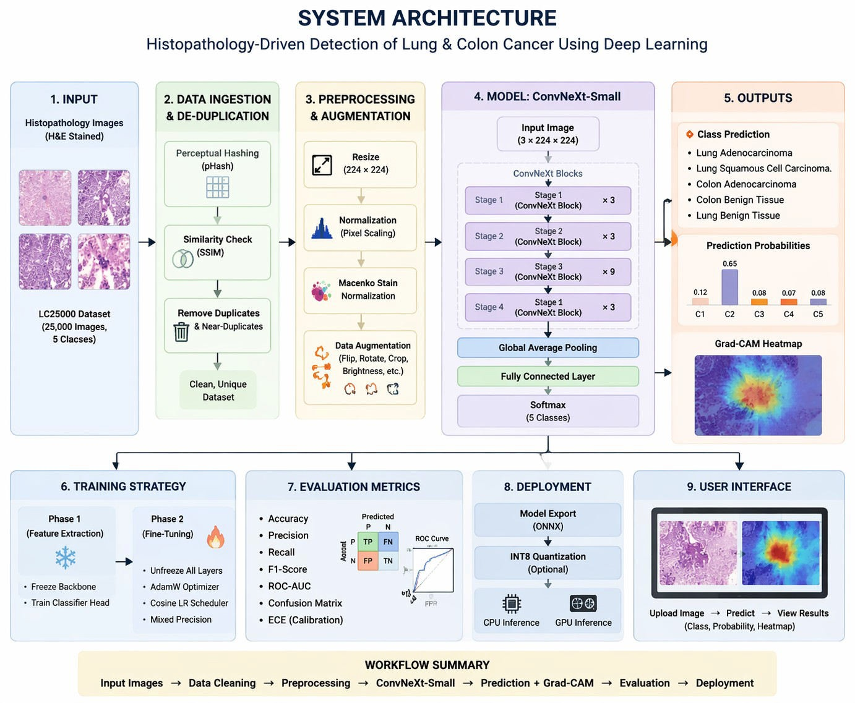

Data Acquisition
3.1 System Architecture

The dataset used in this project is the LC25000 histopathology dataset, which contains 25,000 H&E-stained images across five different tissue classes. These classes include both malignant and benign samples from lung and colon tissues, making the dataset suitable for multi-class classification.
The dataset is well-balanced, with approximately equal representation of each class, which helps in improving model training and reducing bias. The use of a publicly available dataset also ensures reproducibility and standardization of results.

Data Ingestion and De-duplication
To ensure data quality and avoid biased results, a robust data ingestion pipeline is implemented.
A key challenge in machine learning systems is the presence of duplicate or near-duplicate images, which can lead to data leakage.
To address this issue, the system uses perceptual hashing (pHash) to generate unique hash values based

on image structure. Additionally, the Structural Similarity Index (SSIM) is used to measure visual similarity between images. Images that are identified as duplicates or highly similar are grouped together, ensuring that they do not appear across different dataset splits.
Images identified as duplicates are grouped together, ensuring they do not appear across training and validation datasets. This improves the reliability and fairness of model evaluation.

Dataset Splitting
Instead of using random dataset splitting, the system employs a leakage-controlled splitting strategy using GroupKFold or GroupShuffleSplit methods. These techniques ensure that images belonging to the same group (based on hash similarity) are kept together in either training or validation sets.
The dataset is typically divided into:

Training Set (approximately 80%) Validation Set (approximately 20%)
A fixed random seed is used to maintain reproducibility. This method prevents data leakage and ensures that the model is evaluated on truly unseen data.

Preprocessing and Augmentation
Histopathology images often exhibit variations due to differences in staining, lighting, and imaging conditions. To standardize the input data, preprocessing techniques are applied.
Preprocessing steps include image resizing, normalization, and Macenko stain normalization, which helps reduce color variation across images.
To improve model generalization, data augmentation techniques such as rotation, flipping, cropping, and brightness adjustment are applied during training. These transformations increase dataset diversity while preserving important pathological features.

Feature Extraction and Model Architecture
The system uses ConvNeXt-Small, a modern convolutional neural network architecture, for feature extraction and classification. This model is designed to capture complex patterns in histopathology images, including cellular structures and tissue morphology.
ConvNeXt-Small combines the strengths of traditional CNNs with design improvements inspired by transformer architectures, resulting in improved accuracy and efficiency. The model is initialized with
pretrained weights and fine-tuned for the specific task of cancer detection.

This architecture is chosen due to its balance between performance and computational efficiency, making it suitable for both training and deployment.

Training Strategy
The model training is carried out in two stages to ensure stable learning and improved performance.
In the first stage, the backbone of the model is frozen, and only the classification layer is trained. This allows the model to adapt to the new dataset without altering pretrained features.
In the second stage, the entire model is fine-tuned using techniques such as the AdamW optimizer, cosine learning rate scheduling, and mixed precision training. These techniques help improve convergence, reduce training time, and prevent overfitting.

Explainability using Grad-CAM
To enhance transparency and interpretability, the system integrates Grad-CAM, an explainable AI technique that generates heatmaps highlighting important regions in the image.
These heatmaps indicate which parts of the tissue image influenced the model’s prediction, helping medical professionals understand and validate the results. This improves trust in the system and makes it more suitable for clinical applications.
  - Deployment and Output
The final stage of the methodology focuses on deployment and output generation. The trained model is exported to ONNX format, enabling efficient inference across different platforms.
Optional optimization techniques such as INT8 quantization are applied to reduce model size and improve performance. The system generates outputs including predicted class labels, probability scores, and Grad-CAM visualizations.
These outputs provide meaningful insights that assist pathologists in diagnosis and decision-making.

CHAPTER 4
DATA COLLECTION AND CUSTOM DATASET TRAINING

Data Collection
    - Histopathological Image Acquisition
Data collection is one of the most critical stages in developing an effective deep learning system for medical image analysis. In this project, the data used for training and evaluating the proposed cancer detection system was obtained from the LC25000 Histopathological Image Dataset, which is a widely recognized benchmark dataset used in computational pathology research. The dataset contains 25,000 digitized histopathology image patches derived from microscopic tissue slides stained using the Hematoxylin and Eosin (H&E) staining technique.
Histopathology is the gold standard diagnostic technique used by pathologists to detect and classify cancerous tissues. Tissue samples collected from patients through biopsy procedures are processed and stained with Hematoxylin and Eosin to enhance cellular structures. Hematoxylin stains cell nuclei in dark blue or purple tones, while eosin stains cytoplasmic and extracellular structures in pink hues. This staining combination allows pathologists to clearly observe tissue morphology, cellular organization, gland formation, and structural abnormalities that may indicate malignant growth.
The LC25000 dataset contains high-resolution histopathological image patches extracted from whole- slide images (WSIs). These patches represent small sections of tissue that contain meaningful morphological information necessary for cancer classification. The dataset was originally created to support machine learning research in automated cancer detection and has been widely used by researchers for evaluating deep learning algorithms in medical image analysis.
The dataset consists of five balanced diagnostic classes, each containing 5,000 images, ensuring equal representation of all tissue types. The classes included in the dataset are:
- Colon adenocarcinoma
- Colon benign tissue
- Lung adenocarcinoma
- Lung squamous cell carcinoma
- Lung benign tissue

The balanced structure of the dataset is important because it prevents bias during training and allows the
deep learning model to learn features from all tissue categories equally. This helps ensure that the classifier does not disproportionately favor certain classes while neglecting others.

Dataset Characteristics and Diversity

The LC25000 dataset captures realistic histopathological variations commonly encountered in medical imaging environments. Histopathology images are influenced by several factors such as tissue preparation protocols, staining intensity, slide scanning equipment, and biological variability between patients. These factors introduce variations in color distribution, tissue texture, and structural patterns across images.
Such variability is important because it ensures that the trained model is exposed to a wide range of visual patterns, allowing it to generalize effectively to unseen medical images. In real-world clinical settings, pathologists examine tissue slides that may vary in staining intensity, microscope calibration, and tissue orientation. Therefore, a robust machine learning system must be capable of handling such variations.
The dataset includes both benign and malignant tissue samples, enabling the system to distinguish between normal tissue structures and cancerous growth patterns. Malignant tissues often display abnormal cellular architecture such as irregular gland formation, nuclear enlargement, tissue disorganization, and invasive cell growth. In contrast, benign tissues exhibit normal structural organization with uniform cellular distribution.
By training the model on these contrasting patterns, the system learns to identify key histological features associated with cancer detection.

Data Annotation and Feature Preparation

    - Dataset Labeling and Class Identification

Unlike object detection tasks where bounding boxes must be manually annotated, histopathology image classification datasets such as LC25000 are already labeled at the image level. Each image patch in the dataset is assigned a class label representing the tissue category to which it belongs. These labels correspond to the five diagnostic classes mentioned earlier.
Because the dataset is pre-labeled, there is no need for manual annotation using external tools such as LabelImg or annotation platforms commonly used in computer vision tasks. Instead, the dataset structure itself provides clear labeling information that can be directly used for supervised learning.
Each image is organized into directories corresponding to its class label. During data loading, the images are automatically assigned labels based on their directory names, simplifying the dataset preparation process. This structure allows efficient integration with deep learning frameworks such as PyTorch or TensorFlow for training classification models.
This labeling strategy ensures consistency in the training process and reduces the possibility of annotation errors that may occur during manual labeling procedures.

Importance of Data Integrity and Leakage Prevention

A major challenge in machine learning research is ensuring that the dataset is free from duplicate or near-duplicate samples. When similar images appear in both training and validation sets, the model may memorize patterns instead of learning generalizable features. This phenomenon is known as data leakage, which can result in misleadingly high performance metrics.
To address this issue, a perceptual hashing technique was used to detect visually similar images within the dataset. Perceptual hashing generates a compact binary fingerprint representing the structural content of an image. Unlike cryptographic hashing, perceptual hashing remains robust to small variations such as compression artifacts or slight color changes.
Images with identical or very similar perceptual hash values were grouped together into what are known as hash families. These groups were treated as single entities during dataset splitting, ensuring that similar images did not appear across training and validation partitions.
This step is crucial for maintaining the reliability and validity of experimental results.

Dataset Training

    - Dataset Preprocessing

Before training the deep learning model, several preprocessing steps were applied to ensure data consistency and improve the quality of the input images. Histopathology images often exhibit significant color variation due to differences in staining procedures, microscope settings, and slide preparation techniques. If not addressed, these variations may cause the model to focus on irrelevant color patterns rather than meaningful tissue structures.
To mitigate this issue, Macenko stain normalization was applied during preprocessing. This technique standardizes the color distribution of histopathology images by separating hematoxylin and eosin stain
components and adjusting their concentrations relative to a reference image. This normalization process helps reduce color variability while preserving tissue morphology.
After normalization, the images were resized to a standard resolution suitable for deep learning models. For this project, images were resized to 224 × 224 pixels, which is a common input resolution used for convolutional neural networks.
In addition to normalization, pixel intensity values were scaled and standardized using ImageNet normalization parameters. This step ensures compatibility with pretrained deep learning models used during transfer learning.

Data Augmentation

To improve the model's ability to generalize to unseen data, several data augmentation techniques were applied during training. Data augmentation artificially increases dataset diversity by generating modified versions of existing images through controlled transformations.
The augmentation techniques applied include:

- Random horizontal flipping
- Random vertical flipping
- Random rotation by multiples of 90 degrees
- Random cropping and resizing
- Brightness and contrast adjustments

These transformations simulate variations that may occur during tissue slide preparation or microscope imaging. However, augmentation techniques were carefully selected to preserve histological structures and avoid distortion of diagnostic features.
Data augmentation was applied only to the training dataset, while the validation dataset was kept unchanged to ensure unbiased evaluation of model performance.

Training Dataset Distribution
The dataset was divided into training and validation subsets using an 80:20 split strategy. Approximately 20,000 images were used for training, while 5,000 images were reserved for validation. This partition ensures that the model is trained on a sufficiently large dataset while maintaining a separate dataset for performance evaluatio

The dataset statistics are summarized below:

Dataset | Set | Size (Images)
LC25000 Histopathology Dataset | Train | ~20,000
LC25000 Histopathology Dataset | Validation | ~5,000
Total |  | 25,000
Balanced representation of all five tissue classes was maintained across both partitions to ensure fair training and evaluation.

Model Training
The classification model used for this project is based on the ConvNeXt-Small deep learning architecture, which was selected due to its strong performance in image classification tasks and its computational efficiency. The model was initialized using pretrained ImageNet weights to leverage transfer learning.
Training was conducted in two stages. In the first stage, the backbone feature extractor was frozen and only the classification head was trained. This stage allows the classifier to adapt to histopathology features without altering pretrained representations.
In the second stage, the entire network was fine-tuned using a lower learning rate to improve feature extraction for medical images. The training process utilized the AdamW optimizer with cosine learning rate scheduling, ensuring stable convergence and effective parameter updates.
Mixed precision training was employed to reduce GPU memory usage and accelerate training speed. Gradient clipping was also applied to prevent unstable gradient updates during training.
Through this training strategy, the model was able to learn meaningful representations of tissue morphology and achieve high classification accuracy across all five tissue categories.

CHAPTER 5
Histopathology-Driven Cancer Detection: System Architecture, Implementation, and Integration

Introduction
Recent advancements in artificial intelligence and deep learning have enabled the development of automated systems capable of assisting medical professionals in diagnosing diseases using digital medical images. Histopathology, which involves the microscopic examination of tissue samples, remains the gold standard for diagnosing many forms of cancer including lung cancer and colon cancer. However, manual analysis of histopathological slides is time-consuming and requires extensive expertise from trained pathologists.

To address these challenges, this project proposes a deep learning-based histopathology cancer detection system capable of automatically classifying microscopic tissue images into clinically relevant diagnostic categories. The proposed system integrates modern convolutional neural network architectures, data preprocessing techniques, leakage-safe dataset splitting, and explainable AI methods to build a reliable diagnostic framework.

This chapter presents the complete system architecture, implementation details, and integration pipeline used in the development of the histopathology-driven cancer detection system.

System Architecture
The proposed system follows a multi-stage deep learning pipeline consisting of the following modules:

    - Dataset Acquisition Module
    - Data Preprocessing Module
    - Dataset Leakage Prevention Module
    - Deep Learning Model Training Module
    - Model Evaluation Module
    - Explainability Module (Grad-CAM)
    - Model Deployment and Artifact Generation

The overall architecture processes histopathology images and produces diagnostic predictions through a structured workflow.

The pipeline performs the following steps:

- Download and prepare histopathology dataset.
- Detect duplicate images using perceptual hashing.
- Split dataset using group-based splitting to prevent leakage.
- Apply data augmentation and preprocessing.
- Train ConvNeXt-Small deep learning model.
- Evaluate classification performance.
- Generate Grad-CAM visual explanations.

Dataset Acquisition
The dataset used in this project is the LC25000 Histopathology Dataset, which contains microscopic images of lung and colon tissues. The dataset includes 25,000 histopathology image patches representing five diagnostic categories.

The dataset is downloaded directly from Kaggle using the following implementation.

!mkdir -p ~/.kaggle
!cp kaggle.json ~/.kaggle/
from google.colab import files
files.upload() # upload kaggle.json
opencv-python imagehash
!pip -q install kaggle torch torchvision torchaudio tqdm scikit-learn pillow matplotlib
!chmod 600 ~/.kaggle/kaggle.json
!kaggle datasets download -d andrewmvd/lung-and-colon-cancer-histopathological-images

After downloading, the dataset directory is defined as:
DATA_ROOT = Path("/content/lung_colon_image_set")
assert DATA_ROOT.exists(), f"Dataset not found: {DATA_ROOT}"

The dataset consists of the following classes:
- Lung Benign Tissue
- Lung Adenocarcinoma
- Lung Squamous Cell Carcinoma
- Colon Benign Tissue
- Colon Adenocarcinoma

Data Preparation and Class Mapping
Each folder in the dataset corresponds to a specific diagnostic category. The system maps folder names to class labels to ensure consistency during training.

class_map = {
"lung_n": "lung_benign", "lung_aca": "lung_adenocarcinoma",
"lung_scc": "lung_squamous_cell_carcinoma", "colon_n": "colon_benign",
"colon_aca": "colon_adenocarcinoma"
}

This mapping ensures that the classification model produces human-readable predictions rather than folder names
One of the major challenges in training machine learning models is data leakage, which occurs when
duplicate or nearly identical images appear in both training and validation sets. This can lead to artificially inflated performance metrics.
To prevent this issue, the system uses perceptual hashing (pHash) to detect visually similar images.

Perceptual Hashing Implementation

import imagehash from PIL import Image
def compute_phash(fp: str):
img = Image.open(fp).convert("RGB")
return str(imagehash.phash(img))

The computed hash values are used to group visually similar images. These groups are later used during dataset splitting to ensure that similar images are not placed in different partitions.

Leakage-Safe Dataset Splitting
Traditional dataset splitting methods randomly divide data into training and validation sets.
However, when duplicate images exist, this can cause data leakage.

To address this problem, the project uses GroupShuffleSplit, which ensures that images belonging to the same hash group remain in the same partition.

Group-Based Splitting Code

from sklearn.model_selection import GroupShuffleSplit

gss = GroupShuffleSplit(n_splits=1, test_size=0.2, random_state=42) train_idx, val_idx = next(gss.split(X, y, groups=groups))
This approach ensures that similar images are never split across training and validation sets, resulting in more reliable performance evaluation.

Data Augmentation and Preprocessing
To improve generalization and prevent overfitting, several data augmentation techniques are applied during training.
Data Augmentation Pipeline

train_tfm = transforms.Compose([
transforms.RandomResizedCrop(224, scale=(0.6, 1.0)),
transforms.RandomHorizontalFlip(0.5),
transforms.RandomVerticalFlip(0.5),
transforms.RandomRotation(90),
transforms.ToTensor()
])

These transformations simulate variations that occur in real histopathology images, including:

- Tissue orientation changes

- Slide rotation

- Microscopy alignment differences

Validation images are processed without augmentation to ensure unbiased evaluation.

Deep Learning Model Architecture
The classification model used in this project is ConvNeXt-Small, a modern convolutional neural network architecture designed to achieve high performance in image classification tasks.

The model is initialized with ImageNet pretrained weights to leverage transfer learning. Model Initialization Code
from torchvision.models import convnext_small, ConvNeXt_Small_Weights

weights = ConvNeXt_Small_Weights.IMAGENET1K_V1 model = convnext_small(weights=weights)

model.classifier[2] = nn.Linear( model.classifier[2].in_features, len(classes) )

model = model.to(device)

This modification replaces the original classification head with a new layer corresponding to the number of dataset classes.

Model Training Strategy
Training is performed in two stages to improve convergence and performance.

Stage 1: Feature Extraction

During the first stage, the convolutional backbone is frozen and only the classifier layer is trained.

for p in model.features.parameters():
p.requires_grad = False

This allows the classifier to learn domain-specific histopathology features.

Stage 2: Fine-Tuning
In the second stage, the entire network is unfrozen and trained using a lower learning rate to adapt the feature extractor to histopathological textures.

The model is optimized using AdamW optimizer with weight decay regularization.

Explainability Using Grad-CAM
Medical AI systems must provide interpretable results so that clinicians can understand the reasoning behind predictions.

To achieve this, the system integrates Gradient-Weighted Class Activation Mapping (Grad-CAM). Grad-CAM Implementation
class GradCAM: def init(self, model, target_layer): self.model = model self.target_layer = target_layer self.gradients = None self.activations = None
Grad-CAM generates heatmaps highlighting image regions that contributed most to the model's decision.
These visual explanations help verify that the model focuses on relevant tissue structures such as nuclei, glandular formations, and abnormal cellular patterns.

Artifact Generation and Model Storage
After training, the model and associated artifacts are saved for later use and deployment.
Artifact Generation

ART_DIR = Path("/content/artifacts_convnext_leakage_safe")

ART_DIR.mkdir(parents=True, exist_ok=True)

Artifacts include:
    - Trained model weights
    - Class mapping information
    - Grad-CAM visualizations
    - Training logs

The artifacts are compressed and exported.

!zip -r convnext_leakage_safe_artifacts.zip /content/artifacts_convnext_leakage_safe

Model Deployment Preparation
The trained model artifacts can be deployed in real-world applications such as web-based diagnostic tools. In this project, the trained model is saved to Google Drive for later integration with the HistoDetect web interface.

from google.colab import drive drive.mount("/content/drive")

!cp -r /content/artifacts_convnext_leakage_safe
/content/drive/MyDrive/histodetect_models

This step ensures that trained models can be reused without retraining.

Summary
This chapter presented the complete architecture, implementation pipeline, and integration strategy used in the development of the histopathology-driven cancer detection system.

The system combines:
    - leakage-safe dataset splitting
    - data augmentation techniques
    - ConvNeXt-Small deep learning architecture
    - Grad-CAM explainability
    - artifact generation and deployment preparation

By integrating these components, the proposed system provides a robust and interpretable framework for automated cancer detection using histopathology images.

CHAPTER 6
GRAPHICAL USER INTERFACE DEMONSTRATION, RESULTS AND HISTOPATHOLOGICAL DETECTION ANALYSIS

Introduction
The graphical user interface (GUI) serves as the primary interaction layer between users and the artificial intelligence–based histopathological cancer detection system developed in this project. While the deep learning model performs the core computational tasks of feature extraction and classification, the GUI provides a user-friendly platform through which medical professionals, researchers, or general users can upload histopathology images, initiate analysis, and visualize prediction results.

The interface was designed to be intuitive, responsive, and capable of presenting model outputs in a clear and interpretable format. The GUI integrates the trained deep learning model through a backend API and allows real-time inference on uploaded tissue images. This enables users to observe diagnostic predictions and confidence scores without requiring knowledge of the underlying machine learning algorithms.

The graphical interface is implemented using Next.js and React, while the backend inference service is built using FastAPI. Together, these components create a complete web-based AI diagnostic platform that demonstrates the practical applicability of the proposed histopathology detection system.

This chapter demonstrates the graphical interface, presents the experimental results obtained using the trained model, and analyzes the histopathological detection capabilities of the system.

Graphical User Interface Overview
The graphical user interface is structured as a modern web application that consists of multiple sections designed to guide the user through the diagnostic workflow. The interface includes navigation components, disease detection modules, informational pages, and a detection interface where users can upload medical images for analysis.

The GUI architecture follows a modular design pattern in which the user interface communicates with the backend server through REST API calls. The backend processes the uploaded image, performs model inference, and returns the prediction results along with confidence values.
The main features of the GUI include:

    - Interactive landing page
    - Disease detection selection interface
    - Image upload and preview functionality
    - Real-time AI analysis interface
    - Prediction visualization with confidence scores
    - Optional explainability heatmap visualization

This design ensures that the system is accessible to users with minimal technical knowledge while maintaining the analytical capabilities of the underlying AI model.

Landing Page Interface
The landing page serves as the entry point to the application and introduces users to the AI- powered diagnostic platform. The page provides a brief overview of the system’s capabilities and guides users toward the disease detection modules.

The landing page includes:

    - Platform title and description
    - AI-powered diagnostics introduction
    - Navigation menu
    - Call-to-action buttons directing users to detection modules

The landing page also uses animated visual elements and responsive design components to create a professional and engaging interface.
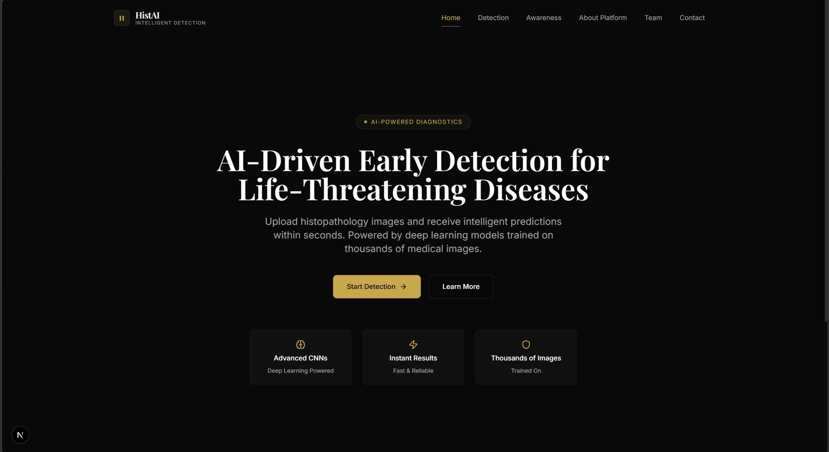
Figure 6.1: Landing Page of the Histopathology Detection System

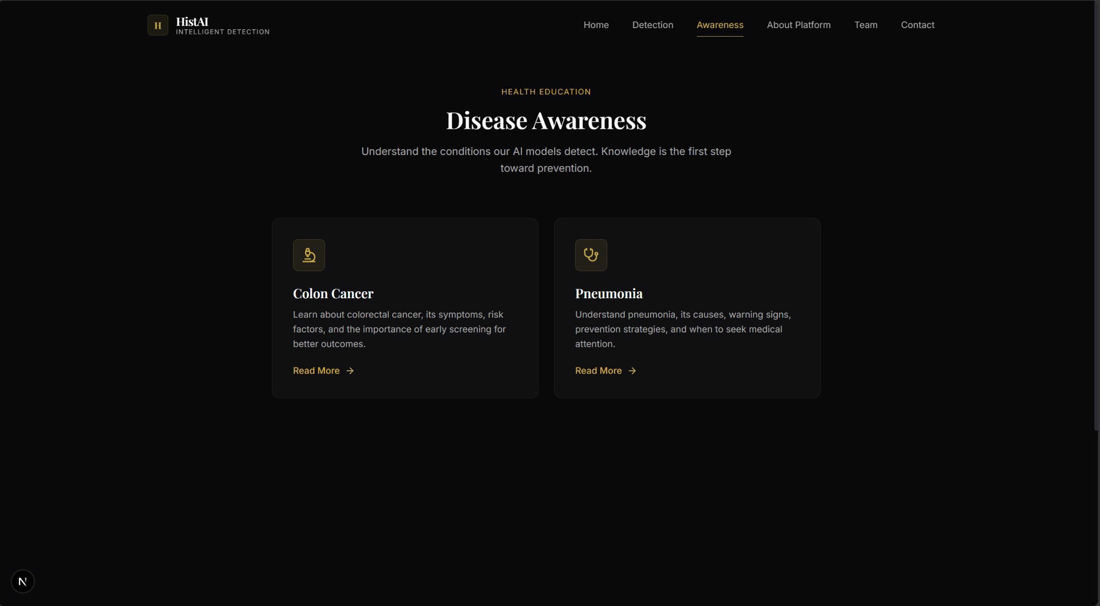
Figure 6.2: Home Page of the Histopathology Detection System
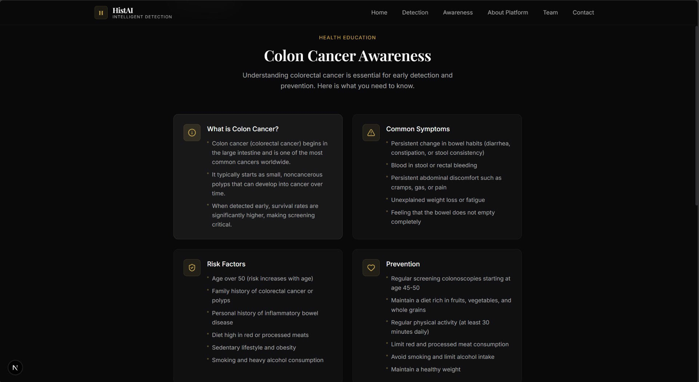

Figure 6.3: Awareness Page of the Histopathology Detection System

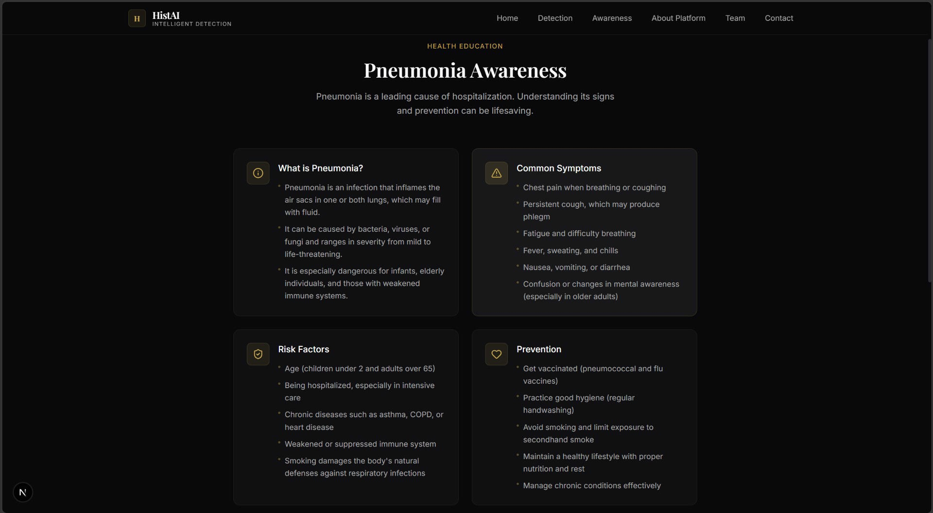

Figure 6.4: Pneumonia awareness page of the Histopathology Detection System
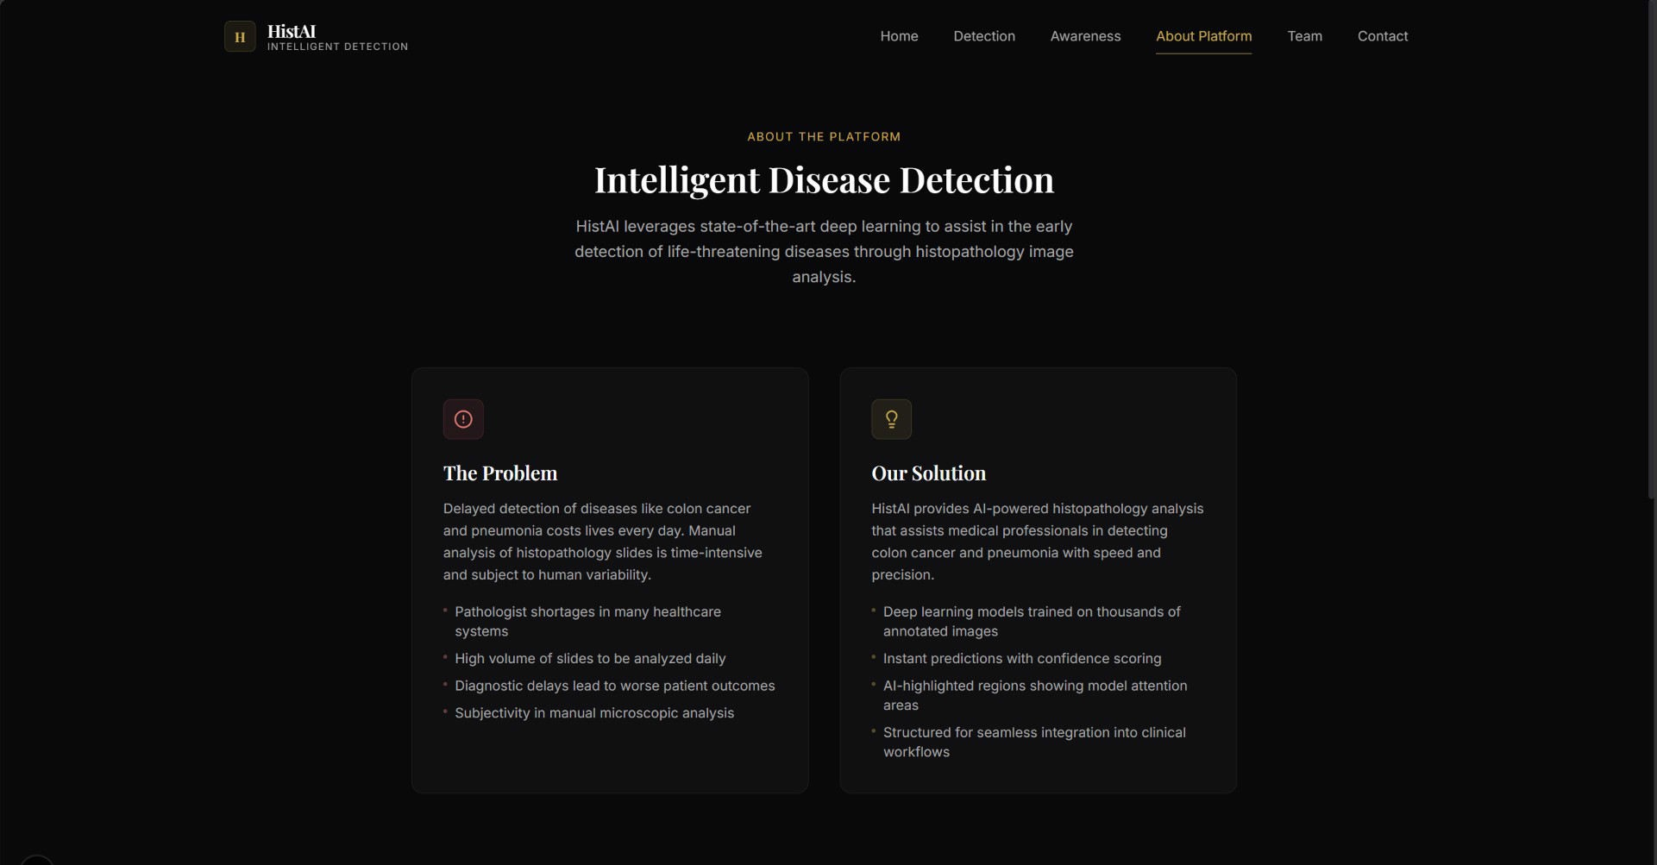
Figure 6.5: Main Detection Page of the Histopathology Detection System

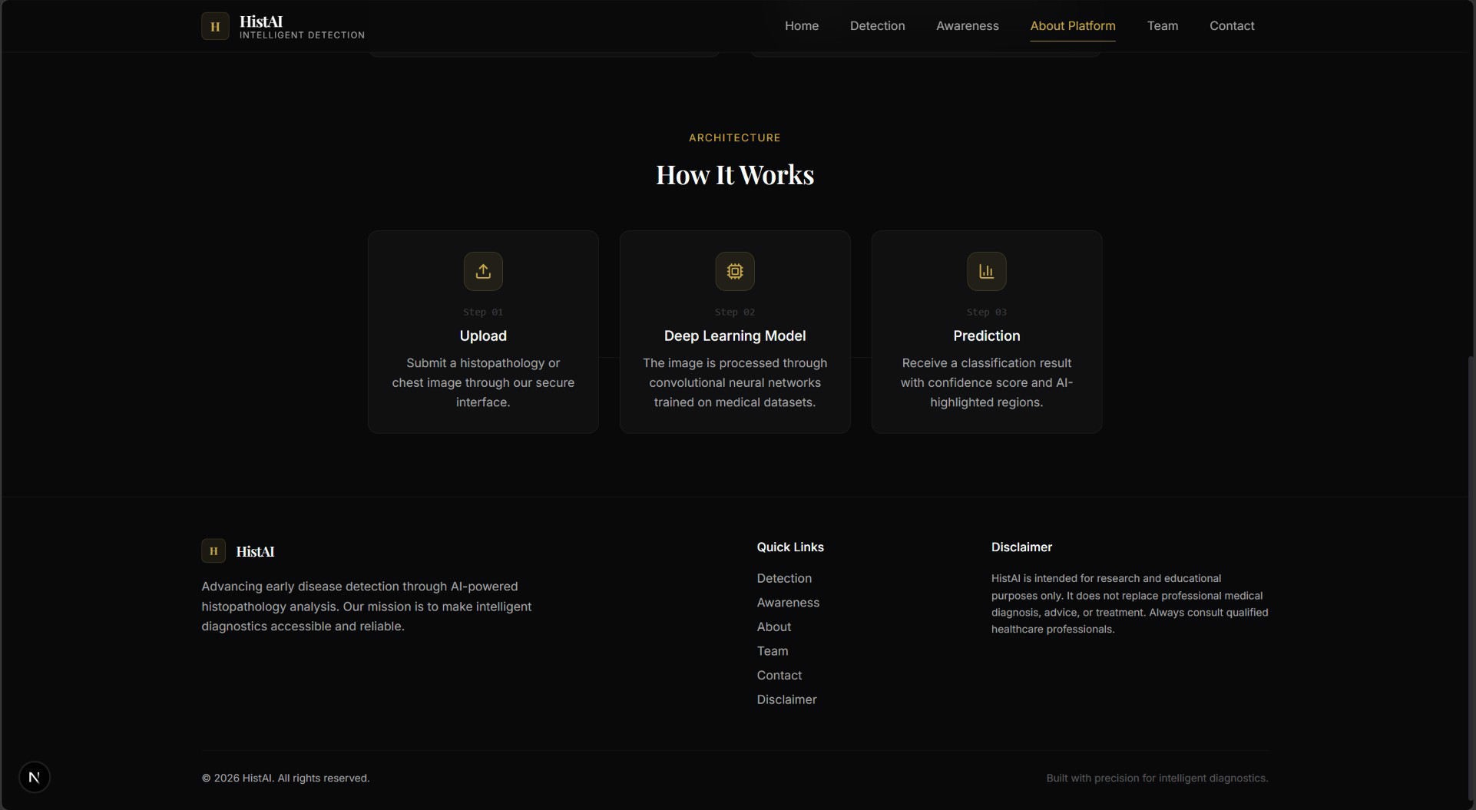
Figure 6.6: Working Instruction Page of the Histopathology Detection System

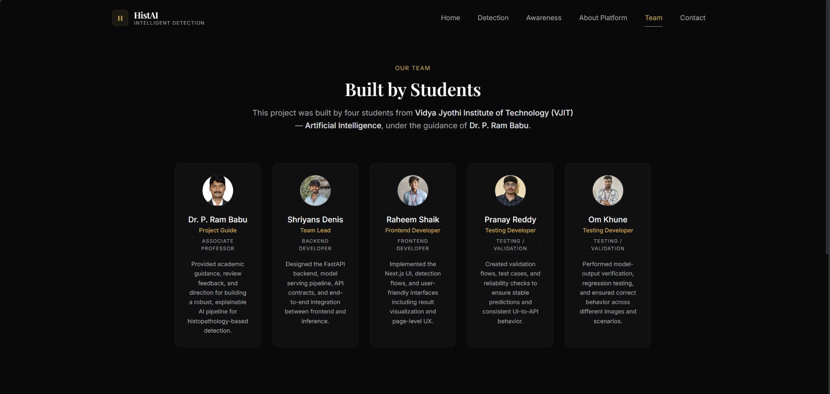
Figure 6.7: About Page of the Histopathology Detection System

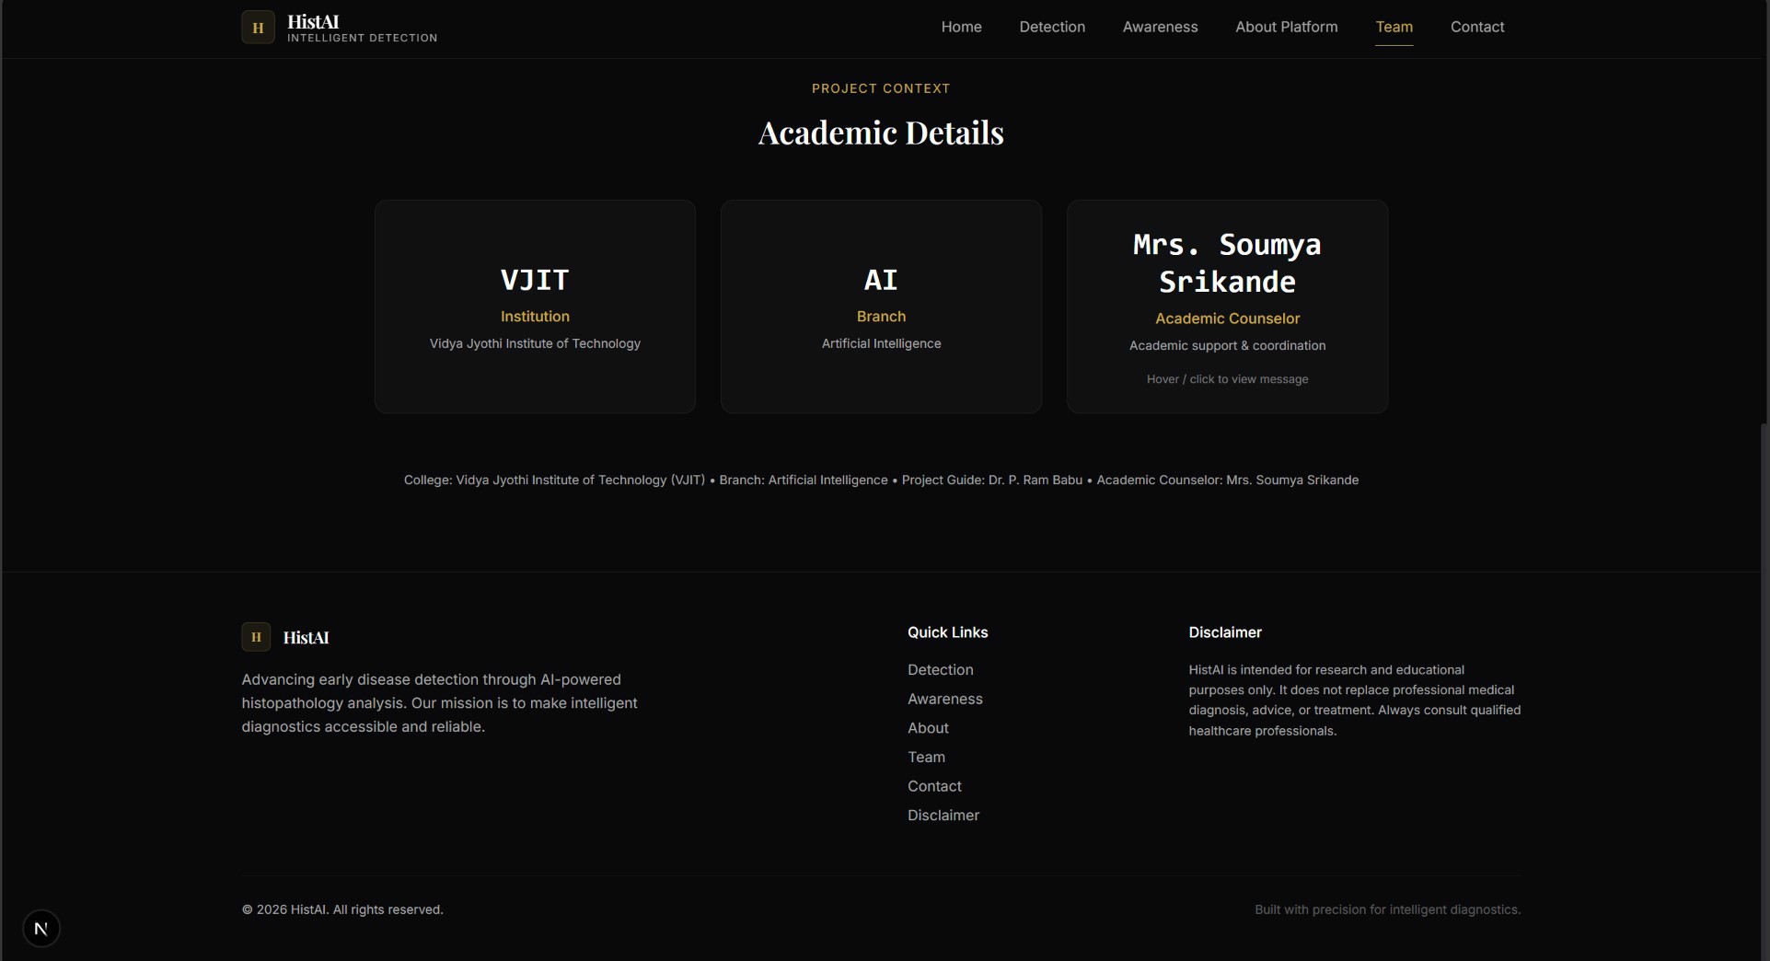
Figure 6.8: About Page of the Histopathology Detection System


Figure 6.9: FAQs Page of the Histopathology Detection System

Disease Detection Selection Interface
After accessing the detection section of the application, users are presented with a selection interface where they can choose the disease detection module they wish to use. This modular design allows the system to support multiple disease detection models under a single platform.

Each detection module is displayed as a card containing the following information:

    - Disease name
    - Brief description of the AI model
    - Button to initiate the analysis process

This design allows the system to be easily extended in the future by integrating additional medical image classification models.
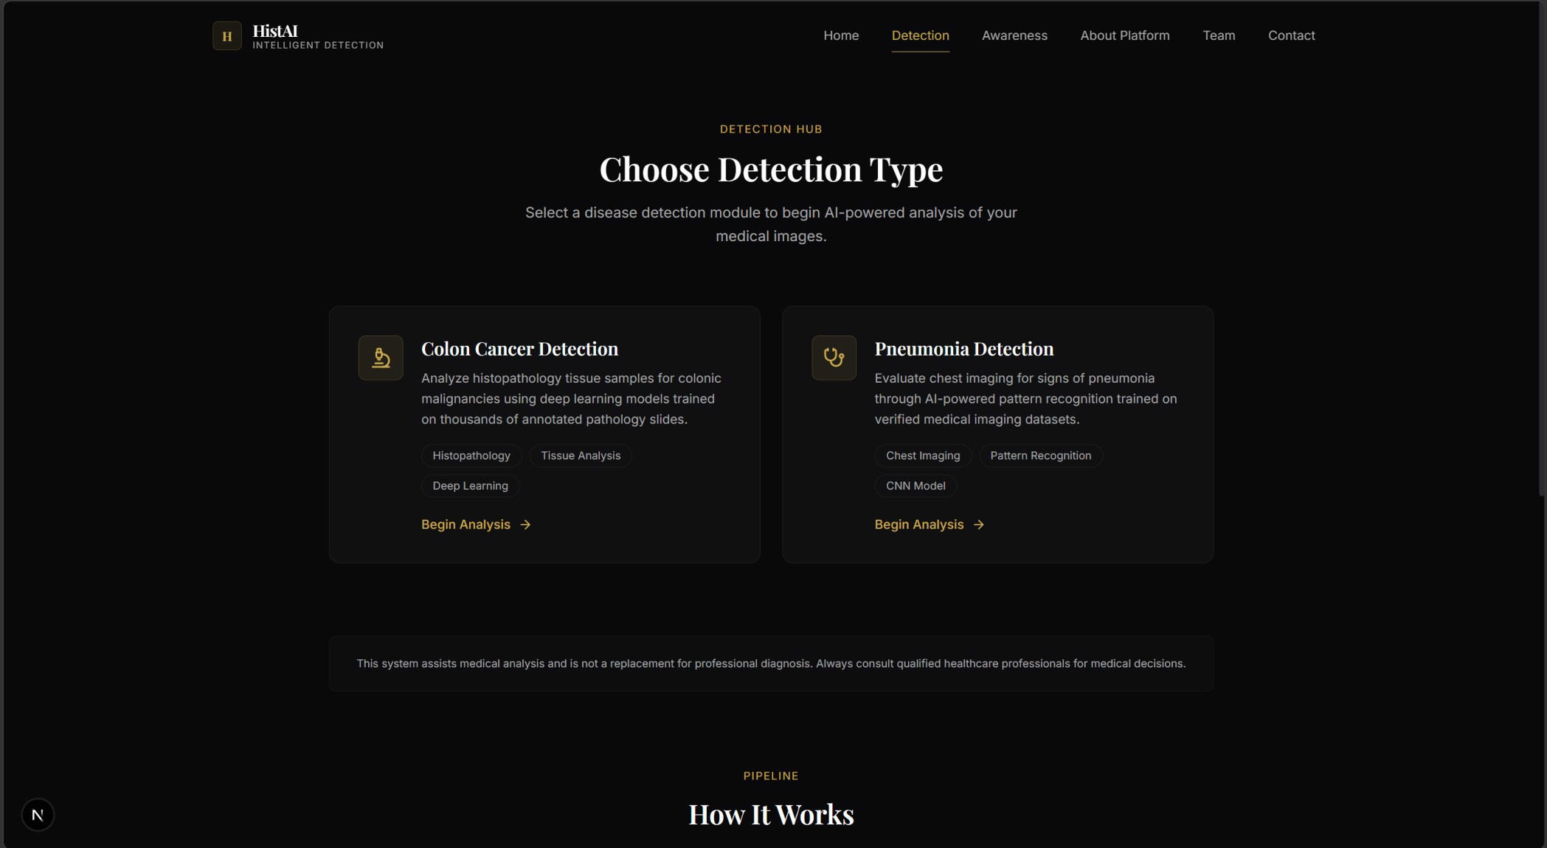
Figure 6.10: Disease Detection Module Selection Interface

Image Upload Interface
Once a user selects a disease detection module, the system displays the image upload interface. This interface allows users to upload histopathology images directly from their device.

The interface supports both:

    - Drag-and-drop image upload
    - Manual file selection

After uploading the image, the system displays a preview of the uploaded tissue image. This allows the user to verify that the correct image has been selected before initiating the analysis.

The interface also performs validation checks to ensure that the uploaded file is a supported image format such as JPG or PNG.
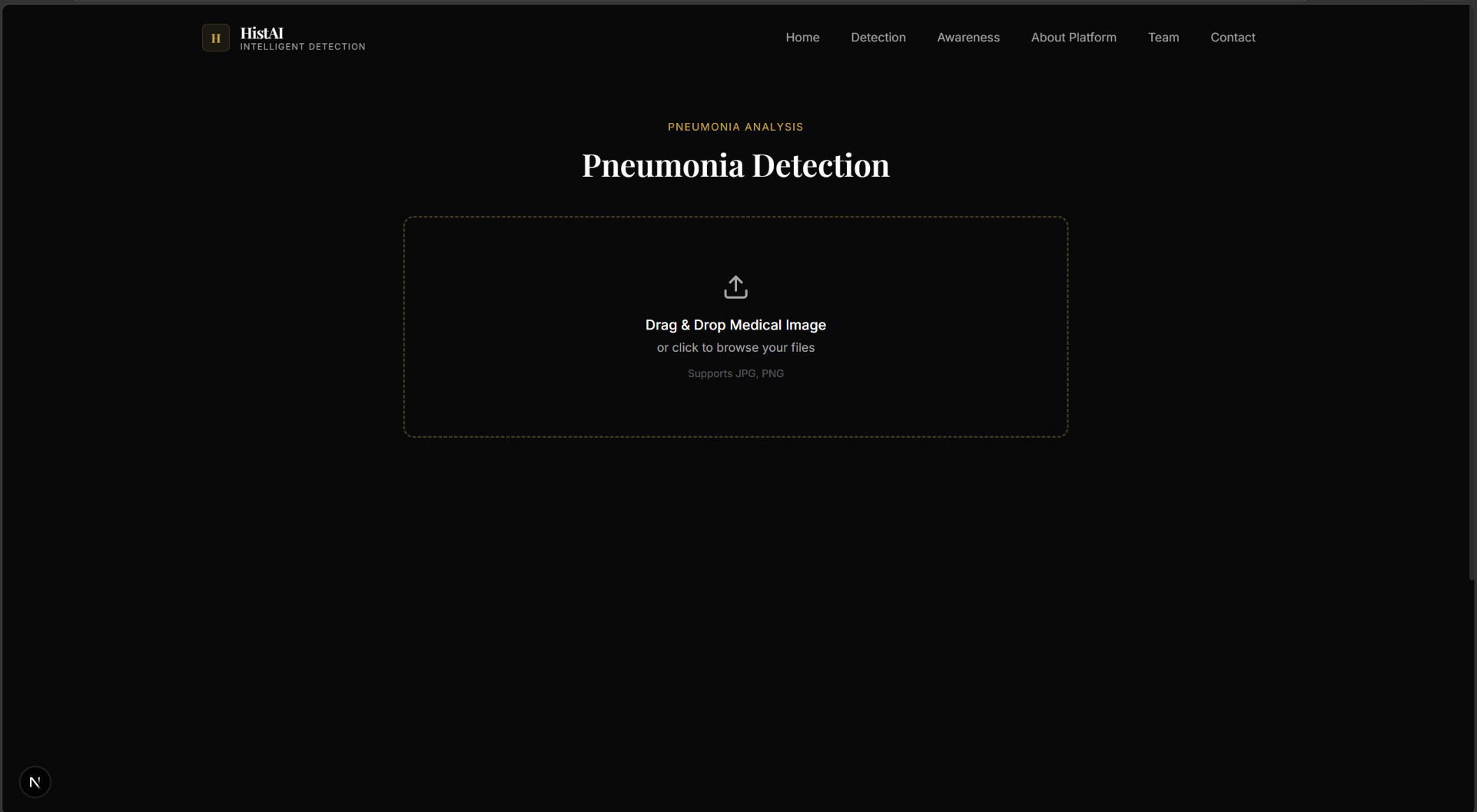
Figure 6.11: Histopathology Image Upload Interface

AI Analysis Interface
After the image is uploaded, the system begins processing the image using the trained deep learning model. During this stage, the interface displays a dynamic analysis screen indicating that the AI model is analyzing the tissue image.

The interface presents informative status messages describing the analysis process, such as:

    - Analyzing cellular morphology
    - Scanning tissue structures
    - Running deep learning inference
    - Detecting abnormal patterns

This feedback improves the user experience by indicating that the system is actively processing the uploaded image.
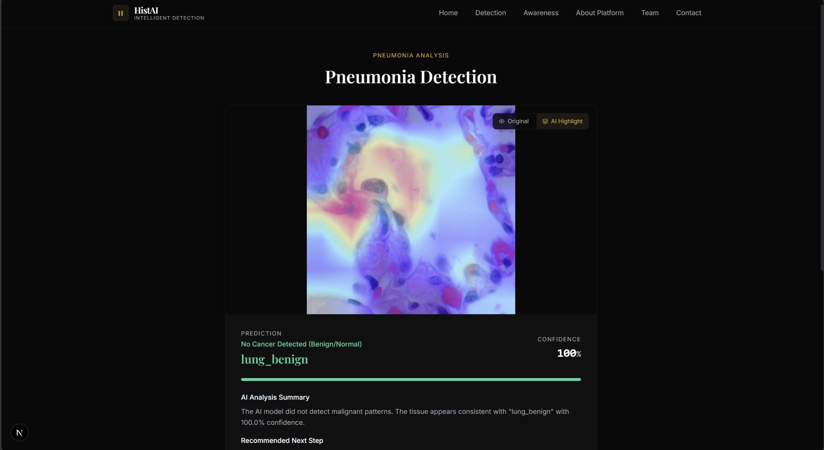
Figure 6.12: AI Analysis Processing Interface

Prediction Results Interface
Once the analysis is complete, the system displays the prediction results. The result interface presents the classification output generated by the deep learning model along with the associated confidence score.

The results include the predicted class label corresponding to one of the histopathology tissue categories. The system also displays the confidence value associated with the prediction, allowing users to assess the reliability of the result.

For example, the system may produce predictions such as:

    - Lung Adenocarcinoma
    - Lung Benign Tissue
    - Lung Squamous Cell Carcinoma
    - Colon Adenocarcinoma
    - Colon Benign Tissue

The prediction confidence is displayed as a percentage, representing the probability assigned by the model to the predicted class.
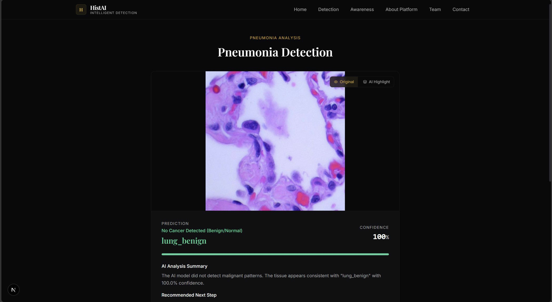
Figure 6.13: Prediction Result Display

Explainability Visualization (Grad-CAM)
To enhance the transparency of the AI model, the system includes an explainability module using Gradient-weighted Class Activation Mapping (Grad-CAM). This technique highlights the regions of the image that influenced the model’s prediction.

Grad-CAM generates a heatmap overlay that indicates which parts of the tissue image were most important for classification. This allows users to visually inspect whether the model is focusing on relevant histopathological features such as abnormal cell clusters or irregular tissue structures.

Explainability is particularly important in medical AI systems because it allows clinicians to verify the reasoning behind model predictions.
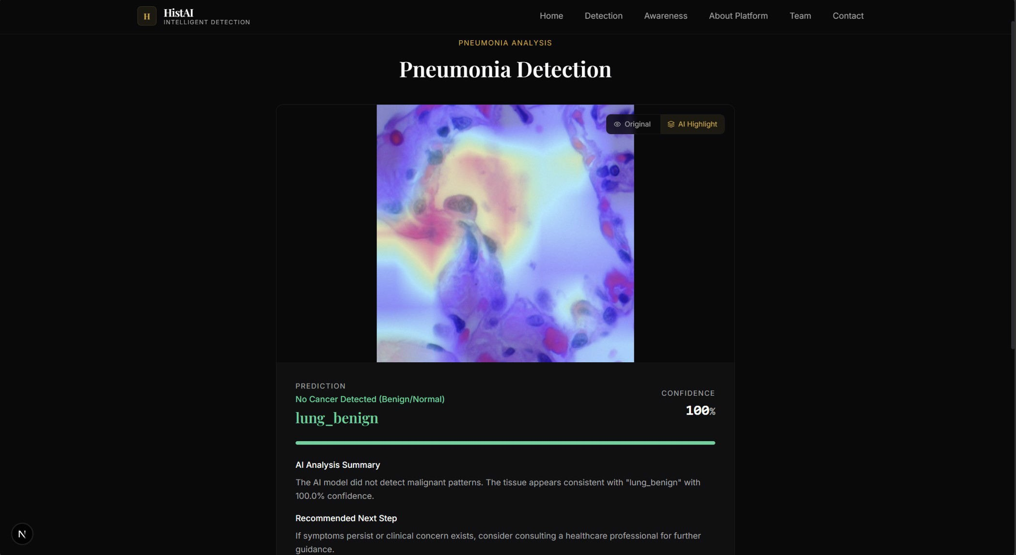
Figure 6.14: Grad-CAM Heatmap Visualization

Experimental Results
The trained ConvNeXt-based model was evaluated using the validation dataset derived from the LC25000 histopathology image dataset. The model achieved strong classification performance across all tissue categories.

The evaluation metrics include:

    - Accuracy
    - Precision
    - Recall
    - F1-score

Evaluation Metrics and Mathematical Formulation
To evaluate the performance of the proposed deep learning model for histopathology-based cancer detection, several standard classification metrics are used. These metrics provide a comprehensive understanding of model performance by analyzing correctness, error distribution, and prediction confidence.

The evaluation is based on the confusion matrix, which consists of the following components:
- True Positive (TP): Correctly predicted positive samples
- True Negative (TN): Correctly predicted negative samples
- False Positive (FP): Incorrectly predicted positive samples
- False Negative (FN): Incorrectly predicted negative samples

Accuracy
Accuracy measures the overall correctness of the model by calculating the ratio of correctly predicted samples to the total number of samples.

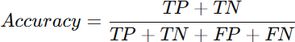

Accuracy provides a general performance overview but may not be reliable when dealing with imbalanced datasets.

Precision
Precision measures how many of the predicted positive samples are actually correct. It is particularly important when false positives are costly.
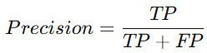

High precision indicates that the model produces fewer false positive predictions.

Recall (Sensitivity)
Recall measures the model’s ability to correctly identify all actual positive samples.

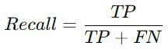

High recall is critical in medical diagnosis, as missing a cancer case (false negative) can have serious consequences.

F1-Score
F1-score is the harmonic mean of precision and recall, providing a balanced measure of both.

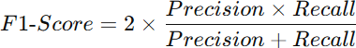

It is especially useful when there is an imbalance between classes.

ROC Curve and AUC
The Receiver Operating Characteristic (ROC) curve represents the trade-off between True Positive Rate (TPR) and False Positive Rate (FPR).

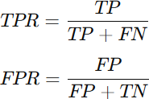

The Area Under the Curve (AUC) measures the model’s ability to distinguish between classes. A higher AUC value indicates better performance.

Expected Calibration Error (ECE)
ECE measures how well the predicted probabilities reflect the true likelihood of correctness.

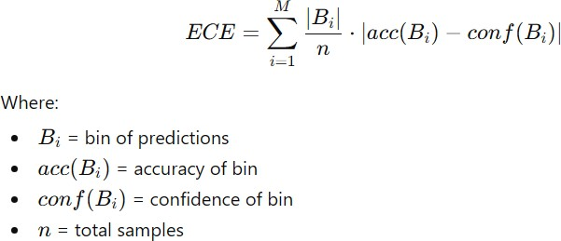
ECE helps ensure that the model’s confidence scores are reliable, which is critical in medical applications.

Loss Function (Cross-Entropy Loss)

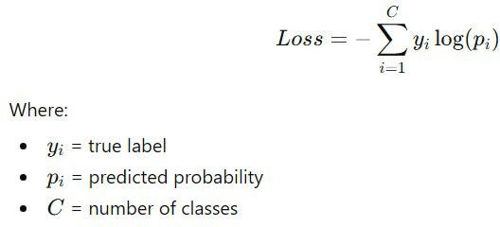
The model is trained using Cross-Entropy Loss, which measures the difference between predicted probabilities and actual labels.

This loss function helps optimize classification performance during training.

Explainability using Grad-CAM
Grad-CAM (Gradient-weighted Class Activation Mapping) is used to visualize important regions influencing the model’s prediction.

The importance weight for feature map kkk is calculated as:

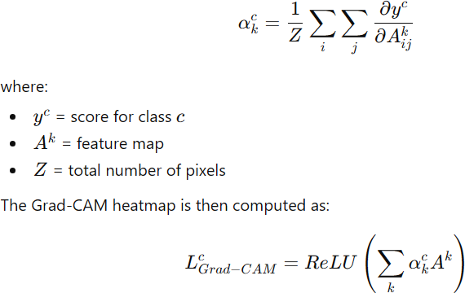
This highlights spatial regions responsible for classification.

Convolution Operation in CNN / ConvNeXt

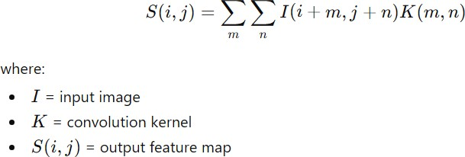

The convolution operation used in CNN-based architectures (including ConvNeXt) is defined as: This operation extracts spatial features such as edges, textures, and tissue patterns.

Softmax Function (Classification Layer)
The final layer of the model converts logits into probabilities using softmax:

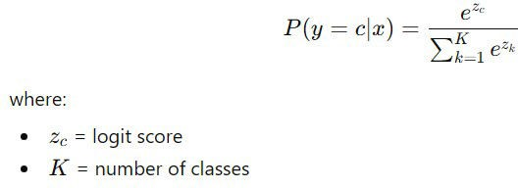

AdamW Optimization Algorithm
The AdamW optimizer updates parameters as follows:
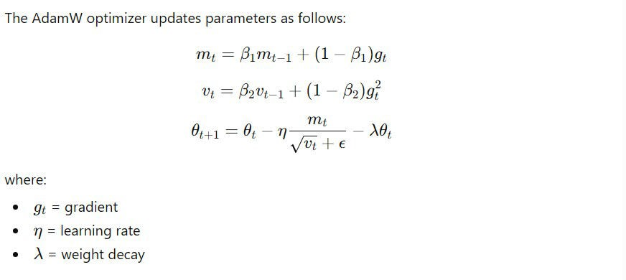

Structural Similarity Index (SSIM)

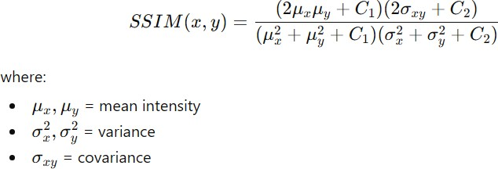

SSIM is used for detecting similar or duplicate images:

Cosine Learning Rate Scheduling
The learning rate is updated using cosine decay:

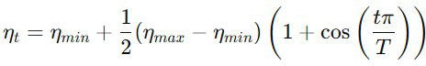

Confusion Matrix
The results indicate that the deep learning model successfully captures discriminative histopathological patterns and can accurately distinguish between benign and malignant tissue samples.

The model demonstrates particularly strong performance in identifying malignant tissue patterns such as adenocarcinoma and squamous cell carcinoma.
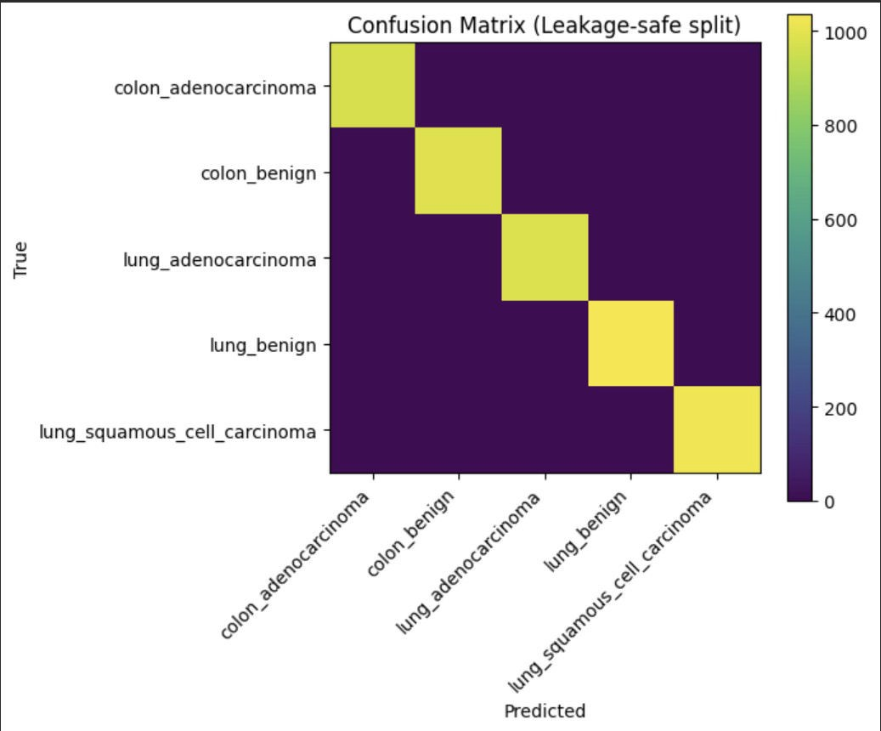
Figure 6.7: Confusion Matrix of Model Predictions

Histopathological Detection Analysis
The proposed system demonstrates strong capability in detecting histopathological abnormalities within microscopic tissue images. The deep learning model learns complex visual features associated with cancerous tissues, including:

    - irregular cell morphology
    - abnormal gland formation
    - increased nuclear density
    - tissue structural disorganization

These features are commonly used by pathologists during manual diagnosis. By learning these patterns automatically, the AI system provides a powerful decision-support tool that can assist clinicians during diagnostic workflows. The Grad-CAM visualizations further confirm that the model focuses on medically relevant regions of the tissue image, indicating that the model’s predictions are based on meaningful histopathological features rather than irrelevant artifacts.

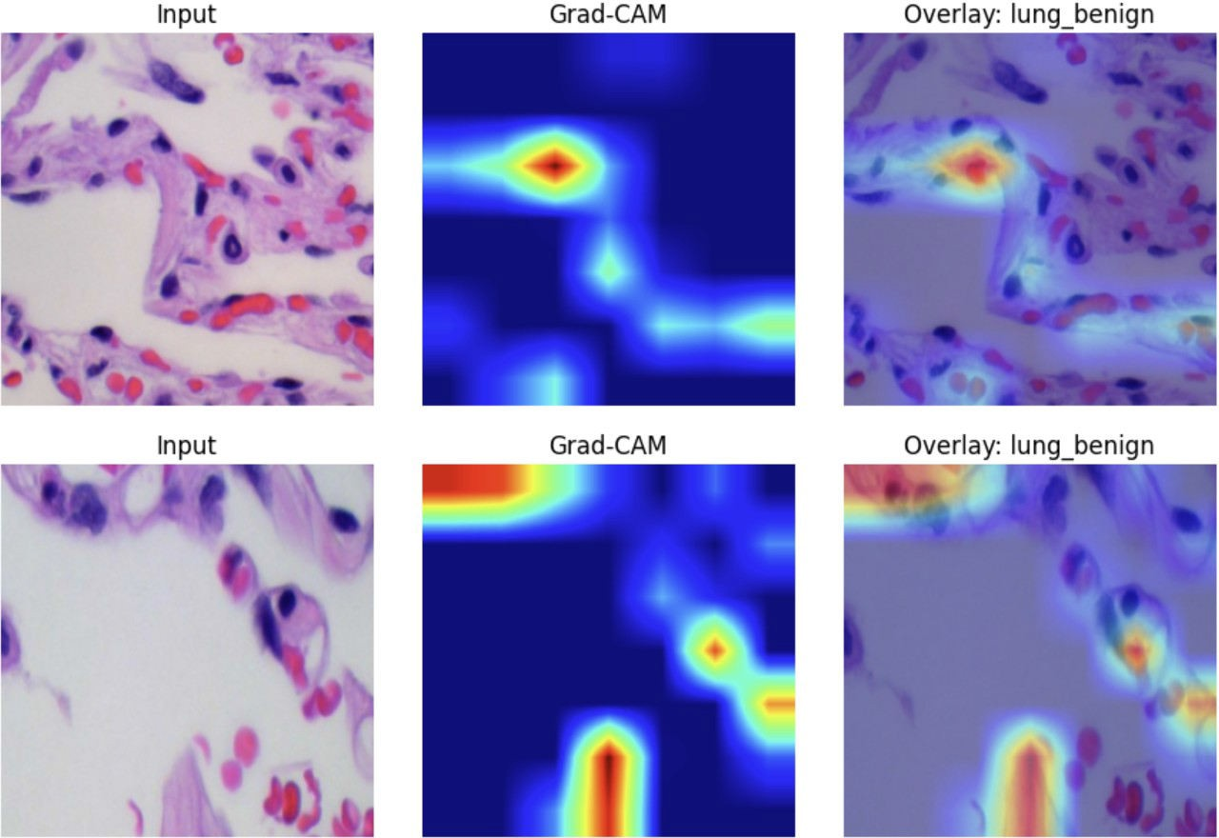

Fgure 6.8: GRAD-CAM Overlay

Summary
This chapter demonstrated the graphical user interface of the proposed histopathology-driven cancer detection system and presented the results obtained using the trained deep learning model. The GUI allows users to upload histopathology images, initiate AI-based analysis, and visualize prediction results through an interactive web interface.
The results indicate that the proposed system can accurately classify histopathological tissue images and identify cancer-related patterns with high reliability. The integration of Grad-CAM explainability further improves the transparency of the system and supports its potential use as a clinical decision-support tool.

Overall, the graphical interface successfully bridges the gap between complex AI models and real-world medical applications by providing a user-friendly platform for automated histopathology analysis.

CHAPTER 7 FUTURE ENHANCEMENTS

Introduction
Although the proposed histopathology-driven cancer detection system demonstrates promising performance in classifying microscopic tissue images, there are several areas where the system can be further enhanced. Artificial intelligence systems in healthcare must continuously evolve to improve diagnostic accuracy, scalability, interpretability, and real-world usability. As medical imaging datasets grow and computational techniques advance, the capabilities of automated diagnostic systems can be significantly expanded.
The current system successfully integrates deep learning–based image classification with a web-based graphical interface, enabling users to upload histopathology images and obtain predictive results along with confidence scores and visual explanations. However, further improvements can be made to enhance the system’s clinical reliability, expand its diagnostic capabilities, and optimize its deployment in real- world healthcare environments.
This chapter discusses potential future enhancements that could improve the performance, scalability, and usability of the proposed histopathological cancer detection system.

Integration with Larger Medical Datasets

One of the most important improvements that can be made to the system is the incorporation of larger and more diverse medical datasets. The current model is trained on the LC25000 dataset, which provides a balanced set of histopathology image patches representing different tissue categories. While this dataset is suitable for research and model development, real-world clinical environments contain far greater variability in tissue structures, staining patterns, and imaging conditions.
Future work could involve training the model using larger datasets derived from multiple hospitals, pathology laboratories, and medical institutions. Incorporating datasets such as The Cancer Genome Atlas (TCGA) or other publicly available histopathology repositories could significantly improve the model’s generalization capability. Training on larger datasets would allow the model to learn more diverse histological patterns and improve its robustness when analyzing unseen tissue samples.
Additionally, integrating multi-institutional datasets would help reduce dataset bias and ensure that the model performs consistently across different populations and laboratory conditions.

Whole Slide Image (WSI) Analysis

The current system operates on image patches extracted from histopathology slides, rather than full whole-slide images. In clinical practice, pathologists typically examine entire digital slides containing large tissue sections rather than small patches. Therefore, a significant enhancement would be extending the system to support whole-slide image analysis.
Whole-slide images can be extremely large, often exceeding several gigapixels in size. To analyze such images effectively, the system would need to implement a patch-based scanning approach in which the slide is divided into smaller tiles that are processed individually. The model could then aggregate predictions from multiple tiles to generate a comprehensive diagnosis for the entire slide.
This enhancement would bring the system closer to real-world pathology workflows and improve its applicability in clinical diagnostic settings.

Multi-Disease Detection Framework

Currently, the system focuses on detecting specific cancer types such as lung and colon cancer based on histopathological images. In the future, the system could be expanded into a multi-disease detection platform capable of analyzing various types of medical images.
Additional detection modules could include:

    - Breast cancer histopathology detection
    - Skin lesion classification using dermoscopy images
    - Brain tumor detection using MRI scans
    - Diabetic retinopathy detection using retinal images

By designing the system as a modular AI diagnostic platform, new disease detection models could be integrated without modifying the existing infrastructure. This would transform the system into a comprehensive medical AI platform capable of supporting multiple diagnostic applications.

Improved Explainable AI Techniques

While the current system incorporates Grad-CAM to provide visual explanations of model predictions, further improvements can be made by integrating more advanced explainable AI techniques. Medical professionals often require interpretable results in order to trust and validate AI-driven diagnostic systems.
Future versions of the system could incorporate additional explainability methods such as:
    - Grad-CAM++, which improves localization accuracy
    - Integrated Gradients, which measures the contribution of each pixel to the prediction
    - SHAP (Shapley Additive Explanations), which provides feature importance explanations

Combining multiple explainability methods would allow clinicians to better understand how the model arrives at its predictions and verify whether the model focuses on medically relevant tissue regions.

Integration with Clinical Decision Support Systems

Another potential enhancement involves integrating the proposed system with clinical decision support systems (CDSS) used in hospitals and pathology laboratories. In such a setup, the AI model would act as an assistive tool that helps pathologists review and analyze tissue slides.
Instead of replacing human expertise, the system could highlight suspicious tissue regions and provide preliminary predictions, allowing pathologists to prioritize cases that require detailed examination. This collaborative approach between AI and medical professionals could improve diagnostic efficiency and reduce the workload of pathologists.
Integration with electronic health record (EHR) systems could also allow the model to incorporate additional patient information, such as medical history and laboratory reports, to provide more comprehensive diagnostic insights.

Real-Time Cloud Deployment

The current system is designed as a web-based application that communicates with a backend inference server. In future implementations, the system could be deployed on cloud platforms to support large-scale usage.
Cloud deployment would enable the system to process images from multiple users simultaneously while ensuring high availability and scalability. Technologies such as containerization (Docker), cloud orchestration platforms (Kubernetes), and serverless architectures could be used to deploy the model efficiently.
Additionally, cloud deployment would allow hospitals and research institutions to access the system remotely without needing specialized hardware for model inference.

Continuous Learning and Model Updating

Machine learning systems benefit from continuous learning as new data becomes available.
Future versions of the system could implement mechanisms for incremental training, allowing the model to update itself using newly collected medical data.
By incorporating feedback from pathologists and clinicians, the system could gradually improve its predictive accuracy and adapt to new diagnostic patterns. Continuous model updating would ensure that the AI system remains relevant and accurate as medical imaging technologies evolve.
However, implementing such systems would require strict validation protocols to ensure that model updates do not compromise diagnostic reliability.

Mobile and Edge Device Integration

To further increase accessibility, the system could be adapted for deployment on mobile devices or edge computing platforms. This would enable medical practitioners in remote or resource- limited environments to access AI-assisted diagnostic tools without requiring high-performance computing infrastructure.
Lightweight versions of the model could be optimized for mobile inference using model compression techniques such as quantization and pruning. Edge deployment would reduce latency and allow real-time image analysis in field settings.
Such capabilities could significantly improve access to diagnostic technologies in rural healthcare facilities and developing regions.

Summary

This chapter discussed several potential future enhancements that could improve the capabilities and real-world applicability of the proposed histopathology-driven cancer detection system. These enhancements include training the model on larger datasets, extending the system to analyze whole- slide images, integrating additional disease detection modules, and incorporating advanced explainable AI techniques.
Further improvements such as cloud deployment, integration with clinical decision support systems, and edge computing support could transform the system into a scalable and accessible medical AI platform. By continuously improving the system through these enhancements, the proposed framework has the potential to become a powerful tool for assisting medical professionals in the diagnosis of cancer and other diseases.

CHAPTER 8 CONCLUSION

Conclusion
The advancement of artificial intelligence and deep learning technologies has significantly transformed the field of medical image analysis. Among the various medical imaging domains, histopathology plays a crucial role in the diagnosis of several life-threatening diseases, particularly cancer. Histopathological examination involves the microscopic analysis of tissue samples to identify abnormal cellular structures, tumor growth patterns, and other morphological features associated with malignant diseases. Traditionally, this process relies heavily on the expertise of trained pathologists who manually examine tissue slides under microscopes. Although this method is highly reliable, it is often time- consuming, labor-intensive, and susceptible to variability in interpretation.
With the growing number of cancer cases worldwide and the increasing demand for faster and more accurate diagnostic tools, the integration of artificial intelligence into histopathological analysis has become an important area of research. Deep learning models, particularly convolutional neural networks, have demonstrated exceptional capabilities in identifying complex visual patterns in medical images. These models can automatically learn hierarchical features from raw image data, allowing them to detect subtle patterns that may not be easily noticeable during manual inspection.
The primary objective of this project was to develop an AI-driven histopathology cancer detection system capable of automatically classifying microscopic tissue images using deep learning techniques. The proposed system combines advanced machine learning algorithms with a user-friendly graphical interface to create a comprehensive diagnostic framework that can assist medical professionals in analyzing histopathological images.
The project involved several stages, including dataset preparation, preprocessing, model training, explainability integration, and system deployment through a web-based interface. The dataset used for training the model consisted of histopathology image patches representing different tissue types associated with lung and colon cancer. These images were preprocessed using normalization and augmentation techniques to ensure consistent data quality and improve the model's ability to generalize across diverse tissue samples.
A key aspect of the proposed system was the use of the ConvNeXt deep learning architecture, which represents a modern evolution of convolutional neural networks designed for high-performance image
classification tasks. ConvNeXt combines the efficiency of traditional convolutional networks with architectural improvements inspired by transformer models. By leveraging pretrained ImageNet weights through transfer learning, the model was able to learn meaningful visual representations of histopathological structures while reducing the need for extremely large medical datasets.
During the training phase, the system utilized a two-stage learning strategy. Initially, the feature extraction layers of the pretrained network were frozen while the classifier layers were trained on the histopathology dataset. This allowed the model to adapt to the new domain while retaining the general visual features learned from large-scale datasets. In the second stage, the entire network was fine-tuned using a lower learning rate to further improve the model’s ability to capture domain-specific tissue patterns.
The experimental results demonstrated that the trained model achieved strong classification performance in distinguishing between benign and malignant tissue samples. The model was able to identify complex histopathological features such as irregular cell morphology, abnormal gland formation, and variations in nuclear density. These characteristics are commonly used by pathologists during manual diagnosis, indicating that the deep learning model successfully learned clinically relevant patterns.
Another important contribution of the project was the integration of explainable artificial intelligence techniques. In medical applications, it is essential that AI models provide interpretable predictions so that healthcare professionals can understand and trust the system's decisions. To address this requirement, the system incorporates Gradient-weighted Class Activation Mapping (Grad-CAM), which generates heatmap visualizations highlighting the regions of the image that influenced the model’s prediction. These heatmaps allow users to verify that the model focuses on relevant histopathological features rather than irrelevant artifacts.
Beyond model development, the project also emphasized practical system deployment. A complete web- based platform was developed to allow users to interact with the AI model through a graphical user interface. The frontend interface was implemented using modern web technologies such as Next.js and React, providing a responsive and intuitive user experience. The backend inference engine was developed using FastAPI, enabling efficient communication between the user interface and the trained deep learning model.
Through this integrated architecture, users can upload histopathology images directly through the graphical interface and obtain prediction results in real time. The system processes the uploaded image, performs model inference, and displays the predicted class along with confidence scores and visualization heatmaps. This demonstrates how deep learning models can be deployed as practical diagnostic tools rather than remaining purely theoretical research models.
The graphical user interface also improves accessibility by allowing users without technical expertise in machine learning to utilize the system. By presenting results in a clear and visually interpretable manner, the interface bridges the gap between complex AI algorithms and real-world medical applications.
The results obtained from this project highlight the potential of artificial intelligence in assisting pathologists with diagnostic tasks. Automated histopathology analysis can significantly reduce the time required for manual examination and help prioritize cases that require immediate medical attention. Instead of replacing medical professionals, such systems can function as decision-support tools that enhance the efficiency and accuracy of clinical workflows.
Although the proposed system demonstrates promising capabilities, it should be noted that the current implementation represents a research prototype. Additional validation using large-scale clinical datasets and collaboration with medical experts would be necessary before deploying the system in real healthcare environments. Nevertheless, the project successfully demonstrates the feasibility of combining deep learning, explainable AI, and web-based technologies to build an intelligent histopathology analysis platform.
Overall, the proposed system contributes to the growing field of AI-assisted medical diagnosis and highlights the potential benefits of integrating machine learning technologies into healthcare applications. With further research and development, such systems could play a significant role in improving cancer detection and supporting clinicians in delivering faster and more accurate diagnoses.
  - Future Work
While the proposed histopathology cancer detection system demonstrates promising results, there are several opportunities for further enhancement and development. Artificial intelligence systems in healthcare must continuously evolve to improve diagnostic reliability, scalability, and real-world applicability. Future research and development efforts can focus on expanding the system’s capabilities, improving model performance, and integrating additional medical functionalities.

One of the most significant areas for future improvement involves the use of larger and more diverse medical datasets. The current model was trained using a publicly available histopathology dataset that contains image patches representing different tissue categories. Although this dataset is suitable for model development and experimentation, real-world clinical data often contain far greater variability in staining patterns, tissue morphology, and imaging conditions. Future work could involve training the model on larger multi-institutional datasets collected from hospitals and pathology laboratories. Such datasets would expose the model to a wider range of histopathological variations, improving its ability to generalize across different clinical environments.
Another important direction for future research is the extension of the system to support whole slide image (WSI) analysis. In clinical pathology workflows, tissue samples are typically digitized into large whole- slide images rather than small image patches. These slides can contain gigapixel-scale images that require specialized processing techniques. Future versions of the system could implement patch-based scanning algorithms that divide large slides into smaller tiles for analysis. Predictions from these tiles could then be aggregated to generate a final diagnosis for the entire slide. This approach would bring the system closer to real clinical workflows and significantly enhance its practical applicability.

Future work could also focus on expanding the system into a multi-disease diagnostic platform. Currently, the system focuses primarily on histopathology-based cancer detection. However, the underlying architecture can easily be extended to support additional medical image classification tasks. For example, detection modules could be added for breast cancer histopathology, skin lesion classification, diabetic retinopathy detection, or brain tumor identification from MRI scans. By integrating multiple disease detection models within a single platform, the system could evolve into a comprehensive AI-powered medical imaging diagnostic tool.

Another important enhancement involves improving the explainability of the AI model. While Grad- CAM provides useful visual insights into the model’s decision-making process, additional explainability techniques could further enhance interpretability. Methods such as Grad-CAM++, Integrated Gradients, or SHAP explanations could be integrated into the system to provide deeper insights into feature importance and model reasoning. Such techniques would increase the transparency of the AI system and strengthen its reliability in clinical applications.

Future research could also explore integration with hospital information systems and clinical decision support systems. By connecting the AI model with electronic health record systems, the system could incorporate additional patient information such as medical history, laboratory results, and imaging reports. Combining image-based analysis with patient data could improve diagnostic accuracy and provide more comprehensive clinical insights.

Another potential improvement involves cloud-based deployment and scalability. Deploying the system on cloud infrastructure would allow multiple users to access the AI diagnostic platform simultaneously from different locations. Cloud computing technologies could enable large-scale processing of histopathology images while ensuring high availability and reliability. Containerization tools such as Docker and orchestration platforms like Kubernetes could further improve system scalability and maintainability.
Finally, future work could explore mobile and edge computing deployment. Lightweight versions of the trained model could be optimized using model compression techniques such as quantization and pruning. This would allow the system to run efficiently on mobile devices or edge computing platforms. Such deployment could enable medical practitioners in remote or resource-limited environments to access AI- based diagnostic tools without requiring powerful computing infrastructure.

In summary, the proposed system provides a strong foundation for AI-assisted histopathology analysis, but numerous opportunities exist for further enhancement. By incorporating larger datasets, improving model explainability, supporting whole-slide image analysis, and expanding deployment capabilities, the system could evolve into a powerful diagnostic tool capable of supporting clinicians in real-world healthcare environments.

CHAPTER 9 REFERENCES
- [1] S. Vanitha, R. Ponnusamy, and S. Kannan, "Deep learning ensemble approach with explainable AI for lung and colon cancer classification using advanced hyperparameter tuning," BMC Medical Informatics and Decision Making, vol. 24, no. 1, Art. no. 112, 2024.
- [2] S. Alsubai, "Transfer learning based approach for lung and colon cancer detection using local binary pattern features and explainable AI techniques," PeerJ Computer Science, vol. 10, Art. no. e1847, 2024.
- [3] Y. Chen, W. Li, and H. Zhang, "Detection and classification of lung cancer cells using Swin Transformer," Journal of Cancer Therapy, vol. 13, no. 4, pp. 199–212, 2022.
- [4] A. Bechar, M. Djerioui, and B. Bekkay, "Harnessing transformers: A leap forward in lung cancer image detection,"
arXiv preprint, arXiv:2311.09942, Nov. 2023.

- [5] R. Kundu, R. Das, Z. W. Geem, and G.-T. Han, "Pneumonia detection in chest X-ray images using an ensemble of deep learning models," PLOS ONE, vol. 16, no. 9, Art. no. e0256630, Sep. 2021.
- [6] V. Ravi, V. Acharya, and M. Alazab, "A multichannel EfficientNet deep learning-based stacking ensemble approach for lung disease detection using chest X-ray images," Cluster Computing, vol. 26, no. 2, pp. 1181–1203, 2023.
- [7] A. Mabrouk, A. Sheraz, M. A. Elfattah, and A. E. Hassanien, "Pneumonia detection on chest X-ray images using ensemble of deep convolutional neural networks," Applied Sciences, vol. 12, no. 13, Art. no. 6448, Jun. 2022.
- [8] A. A. Borkowski, M. M. Bui, L. B. Thomas, C. P. Wilson, L. A. DeLand, and S. M. Mastorides, "Lung and colon cancer histopathological image dataset (LC25000)," arXiv preprint, arXiv:1912.12142, 2019.
- [9] Z. Liu, H. Mao, C.-Y. Wu, C. Feichtenhofer, T. Darrell, and S. Xie, "A ConvNet for the 2020s," in Proc. IEEE/CVF Conf. Computer Vision and Pattern Recognition (CVPR), New Orleans, LA, USA, Jun. 2022, pp. 11976–11986.
- [10] R. R. Selvaraju, M. Cogswell, A. Das, R. Vedantam, D. Parikh, and D. Batra, "Grad-CAM: Visual explanations from deep networks via gradient-based localization," in Proc. IEEE Int. Conf. Computer Vision (ICCV), Venice, Italy, Oct. 2017, pp. 618–626.
- [11] M. Y. Lu, D. F. K. Williamson, T. Y. Chen, R. J. Chen, M. Barbieri, and F. Mahmood, “Data- efficient and weakly supervised computational pathology on whole-slide images,” Nature Biomedical Engineering, vol. 5, pp. 555–570, 2021.
- O. Ciga, T. Xu, and A. Martel, “Self-supervised contrastive learning for digital histopathology,”
Machine Learning with Applications, vol. 7, 100198, 2022.

- C. Guo, G. Pleiss, Y. Sun, and K. Q. Weinberger, “On calibration of modern neural networks,” in
Proc. 34th Int. Conf. Machine Learning (ICML), 2017, pp. 1321–1330.

- M. Gadermayr, J. Toyer, D. Tschuchnig, and collaborators, “Multiple instance learning for digital pathology: A review of current concepts and future trends,” Computerized Medical Imaging and Graphics, 2024.
- X. Jin, J. Liu, Y. Bian, et al., “HistoSSL: Self-supervised representation learning for histopathology images,” Mathematics, vol. 11, no. 1, Art. no. 110, 2022.
- J. Ji and collaborators, “Automated lung and colon cancer classification using deep learning on histopathological images,” 2024.

